



USER MANUAL

EMOTION

This document has been created by the Research and Innovation Department of Central Test and is intended for the internal use of our clients.

It cannot be reproduced or modified, in whole or in part, by any means without the expressed written consent of Central Test.

Central Test - Member of the International Test Commission

Table of Contents
- Introduction 3
  - Main Areas of Application 4
  - Questionnaire Structure 4
  - Mode of Administration, Languages and Special Requirements 4
  - Social Desirability 5
  - Test-taker Requirements and Recommendations 5
  - Administrator Qualifications and Recommendations 5
    - Testing Conditions 6
  - Technical and Security Issues 6
    - Respecting the Ethical Charter 6
    - Confidentiality and Security 6
    - Hardware Architecture and Server Availability 7
  - Supply, Conditions, and Availability 7
- Conceptual and Practical Scale Development 8
  - The history and value of emotional intelligence testing 8
  - Theoretical Application 9
  - Factor Descriptions 10
- Sample Descriptives 13
- Norms 15
- Reliability 25
  - Internal Reliability 25
  - Split-half Reliability 26
  - Test-retest Reliability 26
- Validity 28
  - Concurrent Validity 28
    - EMOTION and IPIP 28
  - Construct Validity 30
    - Inter-Factor Correlations 31
    - Confirmatory factor analysis (CFA) 32
  - Consequential Validity 33
    - Differential Item Functioning 33
    - T-tests and ANOVAs 48
References 52

Introduction
Emotional intelligence can be defined as the ability to understand one's own, as well as other people's emotions, and to manage them in an appropriate way. Emotional intelligence is essential for personal fulfilment and professional success. High levels of emotional intelligence are beneficial to an individual's personal and professional life and are fundamental for serving as a contributing member of an organisation.

EMOTION is a tool designed to assess a person's level of emotional intelligence. This includes the ability to perceive, understand, and manage one’s own emotions, as well as those of others. The corporate version of the assessment is designed to effectively meet the demands of recruitment.
The origins of emotional intelligence can be traced back to 1990, with the work of American researchers Peter Salovey and John Mayer. They gathered the expressions of many behavioural and cognitive abilities that are strongly intertwined, such as:
- The ability to recognise one’s emotions and to understand them
- The ability to manage one’s emotions, especially those that have a depressive or
disruptive effect
- The ability to use one’s emotions to serve a goal
- The ability to identify the emotions of others and to share one's own emotions
- The ability to manage other people's emotions

General intelligence is important for problem solving; however, it is most beneficial to a person's professional and personal life when coupled with emotional intelligence. A certain level of emotional intelligence is crucial during instances when people must work together towards a shared goal, particularly in the corporate world. Furthermore, emotional intelligence is necessary for a person's efficacious adaptation to new situations.
Salovey and Mayer (1990) described emotional intelligence as “a form of social intelligence that involves the ability to monitor one’s own and others' feelings and emotions, to discriminate among them, and to use this information to guide one’s thinking and action". People with a high emotional intelligence score react better to social changes, can perceive things accurately, can understand other people and asses their emotions, and are able to build supportive social networks. A high level of emotional intelligence also provides good judgment when it comes to selecting work that is emotionally rewarding. In this way, emotionally intelligent individuals avoid procrastination, self-doubt, and low levels of achievement, and strive to reach a balance between their personal and professional life, to be self-motivated, and to manage their goals well.

Main Areas of Application
Applications of EMOTION can vary, as it is suitable for individuals, teams, and organisational assessment. It can be applied to employee recruitment, selection, and development processes, as well as for team and individual development, and for culture and employee commitment audits.
After completing EMOTION a report is provided detailing the results of the assessment, which provides a normative emotional intelligence score with a graphical representation of the person’s emotional intelligence. The test-taker is also provided with a summary of his/her emotional profile and the areas that he/she can work on to develop higher emotional intelligence. The report also includes a social desirability indicator to assess the validity of the candidate’s responses.

Questionnaire Structure
EMOTION consists of 15 factors which all measure a different aspect of emotional intelligence. There is an additional factor that serves as a social desirability scale. The final version of the questionnaire is comprised of 96 questions, with each factor containing 6 items. All items are measured on a 4-point Likert scale, where respondents need to specify their level of agreement or disagreement with each item (1 = This does not describe me at all, 2 = This describes me a little, 3 = This describes me fairly well, 4 = This describes me very well). This is the most common form of scoring in normative questionnaires and covers the full range of possible responses.
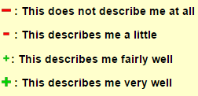

Mode of Administration, Languages and Special Requirements
EMOTION is administered online and is compatible with all computer systems including Windows, MAC-OS, and Linux. The assessment can be administered remotely and without supervision. Reports are solely generated online; therefore, if the test has been administered on paper, the administrator must manually enter candidates’ responses into the Central Test client platform to generate a report.
The questionnaire is available in English. For more information on other language availability, please contact the Central Test Consulting Service at consulting@centraltest.com.
EMOTION was designed to be used by individuals from diverse backgrounds and can be adapted for those with special needs. It is possible to adjust visual screen specifications, such as increasing the font size and screen display. Test instructions are accessible throughout the duration of the assessment for those who require it. Questions can be revisited and changed as desired. For candidates who are blind or have severe visual impairments, items can be read aloud by a trained administrator.

The average time for completion is 15 minutes; however, EMOTION does not have a time limit and therefore candidates who need more time to answer the questions can do so freely. Please contact the test publisher for guidance on administering the questionnaire to individuals or groups with special requirements.

Social Desirability
People are sociable by nature and so are inclined to seek social acceptance. Social desirability is the tendency to present oneself in a manner that will be viewed favourably by others. An individual’s need to present themselves in a favourable light negatively impacts test results (Dodou & de Winter, 2014); therefore it is of utmost importance to control for social desirability in respondents. This is especially true for recruitment purposes, as a candidate will be highly tempted to answer in a way that will impress the recruiter.
In order to control for social desirability, a social desirability scale was constructed for EMOTION. The questions pertaining to the social desirability scale were similar to the other test items in terms of vocabulary and subject; this was done to ensure they were not easily detected. The scale is composed of 6 items, the same as in all other factors.

Test-taker Requirements and Recommendations
EMOTION was designed for members of the general population over 18 years of age that are currently working or looking for work. It is recommended that candidates receive notification of the objective of the assessment, the conditions it will be administered in, how data will be handled and stored, and how the feedback will be delivered. Potential candidates should also be asked beforehand whether they have any special needs or requirements.

Administrator Qualifications and Recommendations
In order to administer EMOTION, practitioners must complete a standardised training course and/or possess accredited testing qualifications.
The aim of the training is to ensure that the test user knows how to:
- Administer the assessment in standardised conditions
- Interpret scores and norms
- Generate written and verbal feedback from the results
- Match the results to a range of organisational needs
Prior to any administration, it is recommended that administrators take EMOTION
themselves. This will enable them to become familiar with it.
Test administration must be in accordance with the organisation’s code of practice and legal regulations on the use of psychometric assessments for employment purposes. It is recommended that international and country laws, such as data protection, discrimination, race and ethnicity relations etc., are taken into account prior to administration. This is to help ensure that the test administration is objective and fair.
Additionally, prior to use, administrators must be familiar with, and adhere to, Central Test’s conditions of use, Code of Ethics, and Quality Charter. Administrators must ensure that:
- The appropriate test(s) has been chosen to meet the organisational needs
- The candidate is informed about the assessment and its purpose prior to administration
- The candidate has given consent prior to administration

- Appropriate norms are used to interpret results
- The candidate is given feedback on the results
- The results and personal information will be deleted on request by the candidate
- The candidate has given consent prior to personal data or results being transferred to third parties
- Only qualified personnel administer assessments and have access to the data
- Assessment materials and reports are stored securely
For more information about Central Test’s Code of Ethics, refer to Central Test’s Quality
Charter.
    - Testing Conditions
EMOTION should be administered in a quiet, well-lit, and ventilated environment, so as to ensure that the candidate is undistracted and has a pleasant experience, thereby increasing the probability that their responses are accurate. Candidates should be allowed sufficient time to take the assessment and should thus be informed about the length of the questionnaire prior to administration. It is best to refer to the assessment as a questionnaire and not a test to reduce candidates’ anxiety levels.
Prior to testing, administrators should ensure that all relevant candidate background information has been collected and verify that the correct candidate is taking the assessment. Candidates receive an email invitation to take the questionnaire, with an embedded link and login details. All web links and login details are unique to a candidate’s account. Expiration dates can be set in order to ensure candidates complete the questionnaire within a specific time-frame.
EMOTION does not have a time restriction; however, time is monitored to allow administrators to know whether a candidate has taken an overly long or short time to complete the questionnaire. Candidates are encouraged to answer questions quickly and spontaneously, in order to provide more accurate answers.

Technical and Security Issues
The following points serve as guidelines for securely administering EMOTION. These are useful for ensuring that EMOTION is administered in an objective and fair manner. Security specifications are also important for protecting the candidate’s information, both during administration and after the completion of the assessment.
    - Respecting the Ethical Charter
As a publisher of online assessment tools, Central Test respects the legal conventions of French labour law and the regulatory provisions resulting from the law of 6 January 1978 pertaining to information technology, files and freedoms: Declaration N°1834067.
Test results and personal data cannot be shared with third parties without explicit consent from the candidate. Candidates have the right to access their results and the assessor must grant them access when requested. Furthermore, if the candidate requests it, all data must be permanently deleted; to do so the candidate must contact either the organisation or Central Test directly.
    - Confidentiality and Security
Central Test guarantees the security and confidentiality of data generated during the administration of online tests: access codes are encrypted in the database and cannot be accessed by anyone. Passwords are computationally generated and not visible to companies. A URL rewriting module (secure link generator) has been installed and has transparent parameter passing for the user.
Browsing and data exchanged via the Central Test application can be secured and represented by an icon in the form of a padlock in the internet browser. The Central Test

application has a <<GeoTrust SSL TRUE BusinessID>> digital signature, issued and certified by GeoTrust®. This certificate protects all Central Test assessments from phishing attacks, and serves as proof of our dedication to providing a secure platform.
Invitations to take tests are made via secured links that are of limited use (in terms of numbers and duration). The tests are timed and IP addresses are tracked.
    - Hardware Architecture and Server Availability
Central Test has a network of ten servers to provide high-quality service. Each server is housed in a specialised data centre featuring:
      - Dedicated lines
      - A guaranteed bandwidth of 100Mbps (per server)
      - Redundant energy sources
      - 4-hour Equipment Restoration time
      - 2-hour Incident Intervention time
      - Monitoring and assistance 24/7/365
Access to the server administration is restricted to an IP address and is password-secured. Data exchanges are secure. Central Test’s application has been tested on and is compatible with the following browsers: Internet Explorer 8 or newer, Firefox 21 or newer, Google Chrome 30 or newer, and Safari 7 or newer.

Supply, Conditions, and Availability
Conditions of supply and availability vary from country to country. However, the following points generally apply: training is compulsory prior to use and distribution; EMOTION can be ordered online or by contacting any Central Test customer service representative or local partner worldwide. The same applies for information about prices and related products and services.

Conceptual and Practical Scale Development

The history and value of emotional intelligence testing
The theoretical roots of Emotional Intelligence (EI) date back to the early 20th century, when it was referred to as ‘social intelligence’ and described as the “ability to understand and manage others” (Thorndike, 1920); although the term owes its widespread popularity to Goleman (2000).
As with general intelligence, there is no consensus on the exact definition of EI; however the main theories share the common concept that emotional intelligence is the ability to recognise and regulate one’s own and others’ emotions (Cherniss & Goleman, 2001). One major distinction between the existing theories of EI is in fact the conceptualisation of the term itself. Ability models stay loyal to this narrow definition, and consider EI as having a specific set of constructs that are necessary to effectively recognise and control emotions; aptitudes that are supposed to overlap with other cognitive abilities (Mayer, Caruso & Salovey, 2000). Trait models, on the other hand, use EI more broadly, as an umbrella term that includes constructs barely or not at all related to cognitive intelligence (Joseph & Newman, 2010); as a composition of intellectual abilities, personality traits and affects (Petrides & Furnham, 2001).
There is a growing amount of research pointing at the importance of emotional intelligence in various aspects of life. Nearly three time as many academic papers on this topic have been published between 2007 and 2012 than between 1995 and 2000 (Schutte, Malouff & Thorsteinsson, 2013). There are numerous studies suggesting that EI is important for success at work. A meta-analysis by Schlaerth, Ensari and Christian (2013) based on 20 studies that involved 5175 participants found a positive association between EI and constructive conflict management. Another meta-analysis based on a sample size of 5795 found EI to be a good predictor of job performance (O'Boyle et al., 2011). EI has also been shown to be associated with physical and mental health. A meta-analysis by Martins, Ramalho and Morin (2010) which examined data from 19815 participants indicated that EI is a stable and sufficient predictor of mental and physical health. Similarly, Schutte, Malouff, Thorsteinsson, Bhullar and Rooke’s (2007) meta-analysis based on 7898 participants found EI to be significantly positively correlated with health. Other studies found EI to be an important factor for sports and relationships. Cricket teams’ performance was found to be positively associated with teams’ EI scores (Crombie, Lombard & Noakes, 2009). Malouff, Schutte and Thorsteinsson’s (2014) meta-analysis found a significant association between EI and romantic relationship satisfaction.
One of the first theories of EI was an ability model by Salovey and Mayer (1990). Salovey and Mayer (1990) identified EI as the “ability to monitor one’s own and other’s feelings and emotions, to discriminate among them, and to use this information to guide one’s thinking and action” (p. 189). The authors drew their ideas from a wealth of findings across different scientific domains (e.g. evolutionary biology, computer science, and psychology), which involved the identification and understanding of emotions to create their Four Branch Model of EI. The four underlying dimensions that Mayer and Salovey (1997) conceptualised are the following: Perceiving emotions is the ability to accurately read other’s emotions (sadness, anger, joy, etc.) from their facial expressions, voice or body language, a crucial base of social communication, and more sophisticated emotional processing. The use of emotions to facilitate thought is the ability to harness the power of emotions to aid cognition. Examples of affection guided cognition can be creativity, or the manifestation of unconsciously processed information in the form of “gut feelings”. Understanding emotions is a skill that builds on the perception of emotions and connecting them with their behavioural manifestation. It is the analysis and understanding of the

emotional motives of people’s actions. Managing emotions is the ability to regulate one’s own and others emotions in order to help achieve certain social or personal goals. There are various instruments to measure EI in the framework of the Four Branch Model, the most recent being the Mayer-Salovey-Caruso Emotional Intelligence Test, or MSCEIT (Mayer, Salovey & Caruso, 2002).
Mayer and Salovey (1997) considered emotional intelligence as an ability, a part of social intelligence. Their model does not doubt the importance of traits in social interactions, but dissociates from them in order to maintain the clarity and cohesiveness of the model. Other theories, such as the Bar-On Emotional-Social Intelligence (ESI) model (Bar–On & Handley, 2003) and the Goleman model (Goleman 1998), widened the scope of investigation to include components not closely related to cognitive abilities.
The ESI model conceptualises EI more openly than Mayer and Salovey (1997), as “an array of non-cognitive capabilities, competencies, and skills that influence one’s ability to succeed in coping with environmental pressures and demands” (Bar–On, 1997, p. 14). Their model includes 15 interrelated social and emotional competencies, skills and facilitators categorised into 5 domains: 1) Interpersonal skills, the ability to be aware of and be able to express oneself includes Self-regard, Emotional Self-awareness, Assertiveness, Independence, and Self-actualisation; 2) Intrapersonal skills, to be socially aware and successfully manage interpersonal relationships includes Empathy, Social Responsibility, and Interpersonal Relationship; 3) Stress management, the regulation and management of emotions includes Stress Tolerance, and Impulse Control; 4)Adaptability, the management of change includes Reality-Testing, Flexibility, and Problem-Solving; and finally, 5) General mood, concerned with self-motivation includes Optimism, and Happiness. The ESI is measured by the Emotional Quotient Inventory (Bar-On, 1997).
Central Test’s EMOTION adopts a trait approach similar to the ESI. One of the reasons for this choice is the importance of the EI test to be practical and informative in business environments. For example, the traits selected for EMOTION are all applicable to the workplace and will allow employers to gain a greater understanding of their employees’ emotional intelligence, how they will work, and how they will interact with others. Furthermore, Martins et al’s (2010) meta-analysis found that when EI was measured as a trait it was more strongly correlated with health than when it was measured as an ability. Central Test’s EMOTION measures 15 competencies that provide a more nuanced picture of EI, and is more specific than the Salovey and Mayer’s (1990) model.

Theoretical Application
Each factor depicted in EMOTION has research to support its importance in everyday life, and therefore enforces the applicability of EMOTION. For example, assertiveness training, developed by behavioural therapists, has been an important tool in behavioural therapy (Bandura, 1969; Mischel, 1968; Ullmann & Krasner, 1965). Mehrabizade, Taghavi and Attari (2009) and Keikhayfarzaneh (2011) found that assertiveness training improved school performance, social skills and decreased social anxiety in high school students. Lin et al. (2004) found that assertiveness training improved medical students’ self-esteem and assertiveness. These findings suggest that assertiveness is a construct that is correlated with a person’s well-being, performance, social skills and therefore is included in Central Test’s EMOTION assessment.
Another example comes from recent research which suggests that expressing emotions can promote the well-being of people who are under stress (Stanton & Low, 2012).
Brans et al. (2014) found that sharing emotions, like anger or sadness, may lead to beneficial effects. A meta-analysis conducted by Frattaroli (2006) demonstrated an overall positive effect of disclosing emotions and feelings. Sharing emotions is believed

to be beneficial in a way that it might result in a catharsis that helps dissolve negative feelings (Scheff, 2007; Littrell, 2008), and expression appears to be a component of almost every therapeutic method (Whelton, 2004). Although empirical evidence is far from conclusive (Brans et al., 2014), and the relationship between expression and negative feelings appears to be very complex (Kennedy-Moore & Watson, 2001; Stanton & Low, 2012), the possible beneficial effect of expressing emotions makes it reasonable to include this domain.
Scott, Colquitt, Paddock, and Judge (2010) found that managers’ empathy had a positive effect on employee well-being, and Kellett, Humphrey, and Sleeth (2002, 2006) found empathy to be the most prevalent predictor of leadership emergence. A study by Sadri, Weber and Gentry (2011) of 37,095 people from 38 countries found that leaders’ empathic acts rated by their subordinates correlated with their performances rated by their supervisors. Scientific evidence therefore clearly shows that empathy is an important domain to measure.
Being able to solve conflicts effectively between parties is a valuable skill to possess for both employer and employee, and has a number of benefits such as the satisfaction of disputants (Bush, 1996; Depner, Cannata & Ricci, 1994), their improved relationship (Johnson & Johnson, 1996; Johnson, Johnson, Dudley, Ward & Magnuson, 1995; Joseph, 1996), or improved problem solving (Fisher, 1997; Smith, 1996). Beyond being beneficial for disputants, mediating has certain benefits for the mediator too, such as reputation (Touval, 1996), or improved social skills (Day-Vines et al., 1996; Shulman 1996). Conflicts at the workplace are inevitable; to be able to mediate between conflicting parties is not only more cost effective than other ways of solving disputes, but also seems to have a positive effect on all parties involved. It is therefore a very useful skill to possess for everybody and a particularly important one for leaders.
In a world where migration has become more prevalent than ever due to globalisation, the demographic of countries has been changing and diversity in the workplace is becoming the norm. Some research suggests that diversity at work results in positive outcomes such as innovation (e.g. Richard, Barnett, Dwyer & Chadwick, 2004), while others suggest that diversity may have negative outcomes such as staff turnover or lowered profitability (Sacco & Schmitt, 2005); although the general consensus appears to be that diversity has the potential for both (Gonzalez & Denisi, 2009). The increasing diversity in the workplace, and the possible benefits and dangers of diversity, makes this construct important to be measured in a comprehensive and practical EI test.
Another important area of emotional intelligence is self-confidence, which is of importance in every aspect of life. People’s self-confidence affects their choice of tasks (Bandura, 1969). Dutton (1995) speculated that failure may hurt people with low more than people with high self-esteem. Dutton and Brown (1997) indeed showed that failure on tasks can result in low self-esteem.
Being optimistic has numerous mental and physical health benefits. A meta-analysis by Rasmussen, Scheier and Greenhouse (2009) of 83 studies found optimism to be a predictor of various physical health outcomes such as less pain, better immune functions, and more positive pregnancy outcomes. Optimism was also found to predict better job performance (Luthans, Lebsack & Lebsack, 2008).

Factor Descriptions
EMOTION consists of 15 factors and a social desirability scale. Each factor captures a different aspect of emotional intelligence. The definitions of the factors can be found below:

Assertiveness refers to the ability to be confident in articulating one's opinion and standing up for what one believes in, even to the extent of causing an argument. People with high scores are able to portray how they are feeling in a manner suitable to the situation they are in. When the situation calls for confrontation, they do not turn away and are able to express their opinions and feelings effectively. People with low scores tend to avoid confrontation and do not generally express their point of view, as they may worry that others may not agree with them or that their opinion could damage relationships.
Dealing with Diversity is the ability to recognise, acknowledge, and accept differences in others. People with high scores respect and welcome people from diverse backgrounds. They readily accept the wide range of variety and make the best use of it. People with low scores tend to find it difficult to come to terms with the diversity around them. They may even find it as a hindrance for progress.
Empathy is the capacity to identify, understand, and relate to the emotions, reactions, and priorities of others. People with high scores are able to make sense of what others are feeling, even if it is not expressed explicitly. They are skilled at detecting emotional cues from people they interact with and reciprocate in a suitable manner. People with low scores tend to find it difficult to interpret and appropriately respond to someone else’s feelings and reactions, especially if they are non-verbal.
Expressing Emotions refers to the ability to be comfortable when clearly conveying how one feels, both verbally and non-verbally. People with high scores are able to clearly convey their emotions to others, which allows them to talk through their feelings and gain support and feedback. People with low scores may find it difficult to clearly convey how they are feeling, which can mean that they tend to internalise their emotions and may not receive support required.
Flexibility refers to the ability to adapt one's thinking process and emotions in order to accommodate new standards and situations. People with high scores tend to be able to easily adapt their emotions and thought process in order to accommodate new situations. They are able to let go of habits and routine thoughts in order to adapt to their new surroundings. People with low scores may find it hard to adapt their thought process and feelings to a new situation. They tend to prefer to remain in familiar surroundings with emotions and thoughts they are accustomed to.
Mediation refers to the ability to mediate and reconcile diverging points of view in situations of disagreement or conflict. People with high scores do not shy away from situations involving conflicts. They try their best to bring about a win-win situation for both parties. People with low scores are not likely to be inclined towards solving conflicts. They might try to move themselves away from frictions and disputes.
Motivating others is the ability to encourage, inspire, and stimulate others into achieving goal-orientated behaviour. People with high scores have the ability to encourage and inspire others to reach their goals. They are able to generate positive emotions and consider other people’s motivations and feelings. People with low scores may find it difficult when encouraging and inspiring others to reach their goals.
Optimism refers to the capacity to face situations and problems with a positive attitude and thought process, while seizing opportunities and seeing the best in everything. People with high scores tend to have a positive thinking style and outlook on life. They are able to seize opportunities by believing that the best is yet to come and that failure is a learning experience. People with low scores can get overwhelmed by certain situations, and may focus too much on failure instead of utilising it as a learning experience.

Resilience is the capacity to quickly recover from adverse and stressful situations. People with high scores have the ability to withstand and bounce back from stressful or disappointing situations, which enables them to have the capacity to overcome adversity. People with low scores tend to find it difficult to recover quickly following a stressful or disappointing situation. They may allow their emotions from this situation to affect them and cloud their judgement.
Self-confidence is having a strong belief in oneself and one's abilities. People with high scores tend to have a strong sense of assurance when it comes to themselves and what they are capable of achieving. They do not doubt themselves and put trust in their own judgement and ability. People with low scores tend to doubt themselves and their abilities. They find it difficult to fully believe in their capabilities and are hesitant when faced with new tasks believing that they do not have the skills or knowledge to succeed, even if they do.
Self-control is the ability to restrain impulses and regulate reactions, while thinking clearly and maintaining adaptive behaviour. People with high scores are able to remain composed and think clearly, by restraining their negative impulses, when faced with difficult situations. They are able to adapt to situations and individuals, and can regulate their reactions to suit their circumstances. People with low scores can appear emotional when faced with difficult situations, as they tend to act upon their impulses and reactions. They may find it difficult to think clearly under pressure and adapt to new or challenging circumstances.
Self-knowledge is the awareness and understanding of oneself and one's emotions, needs, and desires. People with high scores are able to understand themselves and identify how they are feeling, and consequently have a good awareness of why they may feel, think or act in a certain way. People with low scores find it difficult to comprehend why they are acting or feeling a certain way, as they may not yet have a concrete awareness of themselves.
Self-motivation is the ability to guide and direct ones' needs and desires, in order to keep moving towards ones' goals with enthusiasm and a positive attitude. People with high scores are able to direct themselves to ensure that they keep progressing forward with their goals. They tend to guide their positive attitude and enthusiasm to facilitate this process. People with low scores may find it difficult to direct themselves towards their goals, as they may lack enthusiasm and drive to reach these goals.
Self-regard is the realistic appraisal of one's worth, including strengths and limitations. People with high scores have high self-worth and value themselves. They focus on their strengths while recognising their limitations, and are not dependent on what others think of them. People with low scores tend to focus on their shortcomings more than their achievements and strengths. They tend to undervalue themselves and their own worth.
Tactfulness is the ability to put forward one's opinion and views in a subtle and delicate manner, while being considerate about other peoples' feelings, opinions, or position. People with high scores are able to subtly portray their opinions to others when facing tensions, taking into consideration the other peoples' emotions and feelings. People with low scores tend to find it difficult to be subtle when communicating with others in a tension situation. They may lack consideration for other people's feelings by not portraying their opinion in a sensitive manner.

Sample Descriptives
The data presented is from a UK sample of 270 professionals (117 male, 153 female), age range of 18 to 65 (M=43.31, SD=12.60). The sample represents a range of job sectors including finance, medicine, and technology, and a variety of study levels ranging from trades training to PhD.
Table 1 Gender

Gender % |  | N
Male | 43.33% | 117
Female | 56.67% | 153

Table 2 Age

Age (years) | Percentage (%) | N
18 – 25 | 8.52% | 23
26 – 33 | 18.15% | 49
34 – 41 | 16.30% | 44
42 - 49 | 21.11% | 57
50 – 56 | 17.78% | 48
57+ | 18.15% | 49

Table 3 Study Level

Study Level | Percentage (%) | N
Level 5: Trades no training | 8.89% | 24
Level 4: High School Diploma | 27.41% | 74
Level 3: Two Years Vocational Study | 22.22% | 60
Level 2: Bachelor’s Degree | 31.48% | 85
Level 1: Master’s, PhD | 10.00% | 27

Table 4 Socio-professional category

Socio-demographic | Percentage (%) | N
Business Owners | 8.89% | 24
Employees (unskilled, civil service, business) | 17.78% | 48
Independent Professionals | 10.00% | 27
Junior Executives (business, administration, sales) | 15.93% | 43
Junior Executives (education, health, civil service) | 8.15% | 22
Manual Labourers | 7.04% | 19
Merchants or Vendors | 0.74% | 2
Other people without employment | 0.37% | 1
Retirees , Househusbands or housewives | 1.48% | 4

Seeking work | 1.48% | 4
Senior Executives (civil service, business, intellectual or artistic professionals) | 7.04% | 19
Service Providers (B2C) | 2.96% | 8
Skilled Tradespeople | 8.15% | 22
Students (high school/ secondary school) | 0.74% | 2
Students (university) | 1.11% | 3
Technicians, foremen, supervisors | 8.15% | 22

Norms
Norms help in the comparison of an individual’s score with the scores of others who have completed the same assessment. The individuals who took the test are considered representative of the population and so are used for norming. The closer the sample population falls to the target population, the more accurate the distribution will be when used to rank individuals. Norm groups enable us to compare an individual’s score to those of a similar population.
EMOTION was administered to 270 UK working professionals. The sample was provided via the professional research and sampling firm CINT. Respondents received compensation from CINT for their participation. Respondents whose answers were deemed unreliable or those who completed the assessment in under 9 minutes (or under 6 minutes for the retest group) were excluded from the sample, resulting in a final sample of 270 respondents.
Tables 5-9 show the mean, standard deviation, minimum, and maximum scores for the UK sample on the EMOTION factors, and are organised into categories based on study level, age, socio-professional category, and gender.
Table 5 Norms by factors

Score | Mean | Median | Standard Deviation | Standard Error  of Measurement | Minimum | Maximum
AST | 5.67 | 5.80 | 2.24 | 0.14 | 0.00 | 10.00
DWD | 4.95 | 5.00 | 1.97 | 0.12 | 0.00 | 10.00
EMP | 5.74 | 6.30 | 2.20 | 0.13 | 0.00 | 10.00
EEM | 4.37 | 4.20 | 2.40 | 0.15 | 0.00 | 10.00
FLE | 5.18 | 5.00 | 1.87 | 0.11 | 0.00 | 10.00
MED | 5.91 | 6.70 | 2.32 | 0.14 | 0.00 | 10.00
MOO | 5.96 | 6.70 | 2.33 | 0.14 | 0.00 | 10.00
OPT | 4.28 | 4.20 | 2.42 | 0.15 | 0.00 | 10.00
RES | 4.11 | 4.20 | 2.52 | 0.15 | 0.00 | 10.00
SCO | 4.31 | 4.20 | 2.28 | 0.14 | 0.00 | 10.00
SCN | 5.07 | 5.00 | 2.10 | 0.13 | 0.40 | 10.00
SKN | 4.68 | 4.60 | 2.18 | 0.13 | 0.40 | 10.00
SMO | 4.74 | 4.60 | 2.42 | 0.15 | 0.00 | 10.00
SRE | 4.42 | 4.20 | 2.34 | 0.14 | 0.00 | 10.00
TAC | 5.98 | 6.30 | 2.02 | 0.12 | 0.00 | 10.00
AST – Assertiveness ◦ DWD – Dealing with Diversity ◦ EEM – Expressing Emotions ◦ EMP – Empathy
- FLE – Flexibility ◦ MED – Mediation ◦ MOO – Motivating Others ◦ OPT – Optimism ◦ RES – Resilience ◦ SCO – Self-confidence ◦ SMO – Self-motivation ◦ SKN – Self-knowledge ◦ SCN – Self- control ◦ TAC – Tact

Table 6 Gender by factors

Gende r | N |  | AST | DWD | EEM | EMP | FLE | MED | MOO | OPT | RES | SCO | SRE | SMO | SKN | SCN | TAC
 |  | Mean | 5.85 | 4.91 | 5.53 | 4.32 | 5.20 | 5.73 | 5.70 | 4.45 | 4.31 | 4.68 | 5.28 | 4.99 | 4.72 | 5.02 | 5.99
Male | 11  7 | Median | 6.30 | 5.00 | 5.50 | 4.20 | 5.40 | 6.30 | 5.80 | 4.60 | 3.80 | 4.20 | 5.40 | 5.00 | 4.60 | 5.00 | 5.80
 |  | SD | 2.33 | 2.04 | 2.20 | 2.31 | 2.12 | 2.36 | 2.45 | 2.49 | 2.53 | 2.35 | 2.01 | 2.22 | 2.34 | 2.31 | 1.91
 |  | SEM | 0.22 | 0.19 | 0.20 | 0.21 | 0.20 | 0.22 | 0.23 | 0.23 | 0.23 | 0.22 | 0.19 | 0.20 | 0.22 | 0.21 | 0.18
 |  | Mean | 5.53 | 4.99 | 5.90 | 4.41 | 5.17 | 6.04 | 6.16 | 4.15 | 3.96 | 4.03 | 4.91 | 4.44 | 4.75 | 3.97 | 5.97
Femal e | 15  3 | Median | 5.80 | 5.00 | 6.30 | 4.20 | 5.00 | 6.70 | 6.70 | 3.80 | 4.20 | 4.20 | 5.00 | 4.20 | 4.60 | 3.80 | 6.30
 |  | SD | 2.17 | 1.92 | 2.20 | 2.47 | 1.67 | 2.29 | 2.22 | 2.36 | 2.51 | 2.19 | 2.15 | 2.14 | 2.49 | 2.27 | 2.11
 |  | SEM | 0.18 | 0.15 | 0.18 | 0.20 | 0.14 | 0.19 | 0.18 | 0.19 | 0.20 | 0.18 | 0.17 | 0.17 | 0.20 | 0.18 | 0.17
AST – Assertiveness ◦ DWD – Dealing with Diversity ◦ EEM – Expressing Emotions ◦ EMP – Empathy ◦ FLE – Flexibility ◦ MED – Mediation ◦ MOO – Motivating Others ◦ OPT – Optimism ◦ RES – Resilience ◦ SCO – Self-confidence ◦ SMO – Self-motivation ◦ SKN – Self-knowledge ◦ SCN – Self-control ◦ TAC – Tact

Table 7 Age by factors
Age (years) N |  | AST | DWD | EMP | EEM | FLE | MED | MOO | OPT | RES | SCO | SCN | SKN | SMO | SRE | TAC
 | Mean | 6.18 | 4.52 | 6.41 | 3.77 | 4.93 | 6.27 | 6.33 | 4.23 | 3.32 | 3.73 | 4.59 | 3.94 | 4.22 | 4.27 | 6.23
 | Median | 6.70 | 4.60 | 6.70 | 3.80 | 5.00 | 7.10 | 6.70 | 4.20 | 2.90 | 4.20 | 4.20 | 4.20 | 4.20 | 4.20 | 6.70
18 - 25 23 | SD | 2.29 | 2.19 | 1.70 | 1.96 | 1.56 | 2.28 | 2.07 | 1.70 | 1.74 | 1.57 | 2.11 | 1.59 | 1.81 | 1.72 | 1.59
 | SEM | 0.48 | 0.46 | 0.35 | 0.41 | 0.33 | 0.48 | 0.43 | 0.36 | 0.36 | 0.33 | 0.44 | 0.33 | 0.38 | 0.36 | 0.33
 | Mean | 5.64 | 4.64 | 6.05 | 4.12 | 5.36 | 6.08 | 6.19 | 4.42 | 4.18 | 4.41 | 4.67 | 4.69 | 4.42 | 4.30 | 5.70
26 - 33 49 | Median | 5.80 | 4.60 | 5.80 | 3.30 | 5.00 | 6.70 | 6.70 | 4.20 | 3.80 | 4.20 | 4.20 | 4.20 | 3.80 | 4.20 | 5.80
 | SD | 2.18 | 2.12 | 2.09 | 2.63 | 1.84 | 2.55 | 2.48 | 2.38 | 2.62 | 2.51 | 1.96 | 2.56 | 2.27 | 2.52 | 2.18
 | SEM | 0.31 | 0.30 | 0.30 | 0.38 | 0.26 | 0.36 | 0.35 | 0.34 | 0.37 | 0.36 | 0.28 | 0.37 | 0.32 | 0.36 | 0.31
 | Mean | 5.62 | 5.07 | 5.71 | 4.99 | 5.22 | 6.03 | 5.73 | 3.85 | 3.79 | 4.10 | 5.23 | 4.62 | 4.55 | 4.60 | 6.12
 | Median | 5.80 | 5.00 | 6.30 | 5.00 | 5.20 | 6.70 | 6.05 | 3.55 | 4.20 | 4.20 | 5.60 | 4.60 | 4.20 | 4.80 | 6.30
 | SD | 2.30 | 1.70 | 2.12 | 2.38 | 2.01 | 2.41 | 2.53 | 2.58 | 2.57 | 2.27 | 2.03 | 2.25 | 2.22 | 2.59 | 1.76
 | SEM | 0.35 | 0.26 | 0.32 | 0.36 | 0.30 | 0.36 | 0.38 | 0.39 | 0.39 | 0.34 | 0.31 | 0.34 | 0.34 | 0.39 | 0.26
 | Mean | 5.54 | 5.08 | 5.47 | 4.25 | 4.82 | 5.29 | 5.44 | 3.96 | 3.96 | 4.04 | 4.96 | 4.37 | 4.28 | 4.32 | 5.42
 | Median | 5.80 | 4.60 | 5.40 | 3.80 | 5.00 | 5.00 | 5.80 | 3.80 | 3.80 | 4.20 | 5.00 | 4.60 | 4.20 | 4.20 | 5.80
42 - 49 57 | SD | 2.60 | 1.78 | 2.18 | 2.59 | 1.83 | 2.40 | 2.35 | 2.49 | 2.44 | 2.34 | 2.14 | 1.71 | 2.45 | 2.32 | 2.31
 | SEM | 0.34 | 0.24 | 0.29 | 0.34 | 0.24 | 0.32 | 0.31 | 0.33 | 0.32 | 0.31 | 0.28 | 0.23 | 0.32 | 0.31 | 0.31
 | Mean | 5.61 | 5.00 | 4.99 | 4.52 | 5.13 | 5.61 | 5.99 | 4.26 | 4.20 | 4.37 | 4.94 | 4.66 | 4.82 | 3.91 | 5.82
50 – 56 48 | Median | 5.80 | 5.00 | 5.40 | 4.80 | 5.40 | 5.60 | 6.70 | 4.60 | 4.40 | 5.00 | 5.40 | 4.40 | 4.20 | 3.80 | 6.30
 | SD | 2.06 | 2.13 | 2.46 | 2.15 | 1.98 | 2.15 | 2.32 | 2.66 | 2.71 | 2.26 | 2.41 | 2.44 | 2.54 | 2.23 | 1.97
 | SEM | 0.30 | 0.31 | 0.35 | 0.31 | 0.29 | 0.31 | 0.34 | 0.38 | 0.39 | 0.33 | 0.35 | 0.35 | 0.37 | 0.32 | 0.28
 | Mean | 5.72 | 5.18 | 6.18 | 4.35 | 5.57 | 6.48 | 6.33 | 4.92 | 4.81 | 4.95 | 5.83 | 5.44 | 5.92 | 5.08 | 6.83
57+ 49 | Median | 5.80 | 5.40 | 6.70 | 4.20 | 5.80 | 7.10 | 6.70 | 5.00 | 4.60 | 4.60 | 5.80 | 5.00 | 6.30 | 5.00 | 6.70
 | SD | 2.02 | 2.01 | 2.20 | 2.34 | 1.86 | 1.97 | 2.05 | 2.21 | 2.51 | 2.22 | 1.77 | 2.07 | 2.55 | 2.27 | 1.71
 | SEM | 0.29 | 0.29 | 0.31 | 0.33 | 0.27 | 0.28 | 0.29 | 0.32 | 0.36 | 0.32 | 0.25 | 0.30 | 0.36 | 0.32 | 0.24

34 - 41 44

AST – Assertiveness ◦ DWD – Dealing with Diversity ◦ EEM – Expressing Emotions ◦ EMP – Empathy ◦ FLE – Flexibility ◦ MED – Mediation ◦ MOO – Motivating Others ◦ OPT – Optimism ◦ RES – Resilience ◦ SCO – Self-confidence ◦ SMO – Self-motivation ◦ SKN – Self-knowledge ◦ SCN – Self-control ◦ TAC – Tact
Table 8 Study Level by factors

Study Level N AST DW EM
D
P
EE FLE ME
MO OP
O T
RES SC
SC SK
N N
SM SRE TAC

5.2
D
O
M
O
Mean 0
4.70 5.00 3.1
8
4.8
3
4.75 4.85 3.5
4
3.8
5
4.3
6
4.9
2
4.4
5
4.35 4.3
5
5.5
7

Level 5: Trades no training

Media
2 n
4
5.0
0
2.5
4.80 4.95 2.9
0
2.0
5.4
0
2.2
4.60 5.60 3.1
0
2.5
3.7
5
2.5
4.6
0
2.4
5.4
0
1.4
3.8
0
2.4
4.20 4.6
0
2.1
6.0
5
2.0

SD 1 2.05 2.25 9
1 2.00 2.27 8 0 6 0
9 2.15 6 3

0.5
SEM 1
5.8
Mean 1
0.42 0.46 0.4
3
4.86 5.83 4.5
4
0.4
5
5.0
9
0.41 0.46 0.5
3
5.90 5.64 4.0
1
0.5
1
3.7
0
0.5
0
4.1
7
0.2
9
4.6
1
0.5
1
4.5
0
0.44 0.4
4
4.62 4.1
4
0.4
2
5.9
9

Level 4: High School Diploma 7
4

Media n
6.3
0
2.2
5.00 6.30 4.4
0
2.5
5.0
0
1.7
6.70 5.80 4.2
0
2.2
4.0
0
2.2
4.2
0
2.1
4.8
0
2.2
4.4
0
2.0
4.20 4.2
0
2.2
6.7
0
1.9

SD 5 2.04 2.28 5
4 2.40 2.58 9 6 9 3
6 2.52 3 5

0.2
SEM 6
5.7
Mean 6
0.24 0.27 0.3
0
4.96 5.80 4.4
4
0.2
0
4.9
5
0.28 0.30 0.2
7
5.49 6.09 4.2
4
0.2
6
4.6
8
0.2
5
4.3
3
0.2
6
5.4
5
0.2
4
4.6
9
0.29 0.2
6
4.88 4.7
1
0.2
3
5.9
1

Level 3: 2 Years Vocational Training

Media
6 n
5.8
0
5.00 6.40 4.6
0
5.0
0
5.40 6.70 4.2
0
4.2
0
4.4
0
5.8
0
4.6
0
5.00 4.2
0
6.0
5

0 2.2
SD 2
2.02 2.37 2.1
7
1.8
8
2.15 1.95 2.2
7
2.5
8
2.3
1
2.3
8
1.9
8
2.50 2.4
6
2.2
7

0.2
SEM 9
5.6
Mean 1
0.26 0.31 0.2
8
5.18 5.86 4.5
5
0.2
4
5.4
3
0.28 0.25 0.2
9
6.24 6.29 4.6
6
0.3
3
4.2
5
0.3
0
4.5
1
0.3
1
5.3
8
0.2
6
5.0
8
0.32 0.3
2
4.93 4.7
4
0.2
9
6.1
7

Level 2: Bachelor's Degree

Media
8 n
5
5.8
0
2.1
5.00 5.80 4.2
0
2.3
5.0
0
2.0
6.70 6.70 4.2
0
2.5
4.2
0
2.6
4.2
0
2.3
5.4
0
2.0
5.0
0
2.3
4.60 5.0
0
2.4
6.3
0
1.9

SD 9 1.99 2.02 9
4 2.39 2.30 2 0 3 0
1 2.45 2 3

0.2
SEM 4
5.7
Mean 1
0.22 0.22 0.2
6
4.71 5.62 4.2
6
0.2
2
5.5
0
0.26 0.25 0.2
7
6.84 6.47 4.5
6
0.2
8
3.7
8
0.2
5
3.9
9
0.2
2
4.6
9
0.2
5
4.0
6
0.27 0.2
6
4.45 3.6
6
0.2
1
5.8
9

Level 1: Master's, PhD

Media
- n
7
5.8
0
2.2
4.60 5.80 3.3
0
2.5
5.8
0
1.1
7.10 6.70 4.2
0
2.5
3.3
0
2.7
3.8
0
2.2
4.6
0
1.6
4.2
0
2.1
4.20 3.8
0
2.1
5.8
0
1.9

SD 7 1.56 2.14 8
9 2.05 2.24 1 4 3 1
9 2.16 5 7

0.4
SEM 4
0.30 0.41 0.5
0
0.2
3
0.39 0.43 0.4
8
0.5
3
0.4
3
0.3
1
0.4
2
0.42 0.4
1
0.3
8

AST – Assertiveness ◦ DWD – Dealing with Diversity ◦ EEM – Expressing Emotions ◦ EMP – Empathy ◦ FLE – Flexibility ◦ MED – Mediation ◦ MOO – Motivating Others ◦ OPT – Optimism ◦ RES – Resilience ◦ SCO – Self-confidence ◦ SMO – Self-motivation ◦ SKN – Self-knowledge ◦ SCN – Self-control ◦ TAC – Tact
Table 9 Socio-professional Level by factors

Job | N |  | AST | DW D | EM P | EE M | FLE | ME D | MO O | OP T | RES | SC O | SC N | SK N | SM O | SRE | TAC
 |  | Mean | 6.3  3 | 5.34 | 6.56 | 5.26 | 5.3  0 | 6.55 | 7.10 | 4.3  0 | 4.3  7 | 4.6  7 | 5.2  3 | 5.05 | 5.27 | 5.2  3 | 6.8  8
Business Owners
 | 2  4 | Media  n | 6.7  0 |  |  |  | 5.4  0 |  |  | 4.2  0 | 4.2  0 | 4.8  0 | 5.0  0 |  |  | 5.2  0 | 6.9  0
 |  |  |  | 4.80 | 6.90 | 5.40 |  | 6.90 | 7.10 |  |  |  |  | 4.80 | 4.80

Job N AST DW EM D P
EE FLE ME
M D
2
MO OP
O T
5

RES SC O
SC SK
N N

SM SRE TAC O
4

SD 2.2
9
2.12 1.57 2.34 2.0
2.09 1.41 2.3
2.8
2
2.6
0
2.3
3
2.08 2.50 2.8
1.9
0

 |  | SEM  Mean | 0.4  7  5.0  4 | 0.43  4.86 | 0.32  5.43 | 0.48  3.73 | 0.4  1  5.2  6 | 0.43  4.68 | 0.29  4.61 | 0.4  8  3.8  3 | 0.5  8  3.9  2 | 0.5  3  4.0  4 | 0.4  7  4.5  9 | 0.43  4.46 | 0.51  4.49 | 0.5  8  4.2  2 | 0.3  9  5.2  4
Employees | 4  8 | Media n  SD | 5.0  0  2.2  5 | 5.00  1.75 | 5.40  2.16 | 3.10  2.39 | 5.6  0  1.9  0 | 4.20  2.17 | 4.80  2.24 | 3.8  0  2.2  6 | 4.0  0  2.0  5 | 4.2  0  1.8  6 | 4.4  0  1.9  3 | 4.20  1.86 | 4.20  2.58 | 4.2  0  1.9  6 | 5.8  0  2.0  0
 |  | SEM  Mean | 0.3  3  5.8  6 | 0.25  4.81 | 0.31  5.56 | 0.34  4.80 | 0.2  7  5.5  7 | 0.31  6.41 | 0.32  6.29 | 0.3  3  5.1  6 | 0.3  0  4.2  3 | 0.2  7  4.6  7 | 0.2  8  5.0  7 | 0.27  5.18 | 0.37  4.70 | 0.2  8  4.4  9 | 0.2  9  6.1  2
Independent | 2 | Media n | 5.8  0 | 4.60 | 6.30 | 4.60 | 5.8  0 | 7.50 | 6.70 | 5.0  0 | 4.2  0 | 5.0  0 | 5.0  0 | 5.00 | 4.20 | 3.8  0 | 6.7  0
Professionals | 7 | SD | 1.8  6 | 1.68 | 2.29 | 1.94 | 1.4  0 | 2.33 | 2.19 | 2.3  2 | 2.2  8 | 2.0  4 | 2.0  5 | 2.27 | 2.26 | 2.0  6 | 1.7  8
 |  | SEM  Mean | 0.3  6  5.9  0 | 0.32  5.36 | 0.44  5.96 | 0.37  4.85 | 0.2  7  5.2  3 | 0.45  6.60 | 0.42  6.42 | 0.4  5  4.2  6 | 0.4  4  4.1  3 | 0.3  9  4.3  6 | 0.3  9  5.4  2 | 0.44  4.84 | 0.43  4.83 | 0.4  0  4.2  2 | 0.3  4  6.3  7
Junior Executives (business | 4 | Media n | 6.3  0 | 5.40 | 6.30 | 4.60 | 5.4  0 | 7.50 | 6.70 | 4.2  0 | 3.8  0 | 4.2  0 | 5.8  0 | 5.00 | 4.20 | 4.2  0 | 6.7  0
administration,  sales) | 3 | SD | 2.1  6 | 2.19 | 2.29 | 2.70 | 1.7  5 | 2.31 | 2.12 | 2.3  0 | 2.6  9 | 2.1  6 | 2.3  5 | 2.30 | 2.68 | 2.2  1 | 2.1  7
 |  | SEM | 0.3  3 | 0.33 | 0.35 | 0.41 | 0.2  7 | 0.35 | 0.32 | 0.3  5 | 0.4  1 | 0.3  3 | 0.3  6 | 0.35 | 0.41 | 0.3  4 | 0.3  3
Junior Executives (education, | 2 | Mean | 5.2  6 | 4.59 | 6.02 | 3.45 | 5.0  0 | 6.62 | 6.72 | 4.6  6 | 3.7  6 | 4.0  1 | 5.5  9 | 4.31 | 4.67 | 3.9  9 | 6.2  0
health, civil  service) | 2 | Media n | 5.0  0 | 5.00 | 6.30 | 2.90 | 5.0  0 | 6.70 | 7.30 | 4.8  0 | 3.5  5 | 3.8  0 | 5.8  0 | 5.00 | 4.20 | 3.8  0 | 6.3  0

Job N AST DW EM D P
EE FLE ME
M D
2
MO OP
O T
8

RES SC O
SC SK
N N

SM SRE TAC O
0

SD 2.4
4
1.84 1.98 1.93 1.5
1.95 2.26 2.4
2.3
9
2.1
8
1.9
4
2.01 2.16 2.3
1.8
6

 |  | SEM  Mean | 0.5  2  4.7  0 | 0.39  5.03 | 0.42  4.44 | 0.41  3.48 | 0.3  2  4.5  4 | 0.42  5.54 | 0.48  6.21 | 0.5  3  3.0  8 | 0.5  1  3.9  5 | 0.4  7  3.4  7 | 0.4  1  5.1  8 | 0.43  3.81 | 0.46  4.35 | 0.4  9  3.6  1 | 0.4  0  6.0  1
Manual labourers | 1  9 | Media n  SD | 5.0  0  2.7  7 | 5.00  1.68 | 3.80  2.31 | 2.90  2.52 | 5.0  0  2.0  9 | 5.00  2.50 | 6.70  2.99 | 2.9  0  2.2  8 | 4.2  0  2.3  9 | 2.9  0  2.2  8 | 5.4  0  1.9  9 | 3.80  1.92 | 5.00  2.66 | 3.3  0  2.5  3 | 6.3  0  1.7  6
 |  | SEM  Mean | 0.6  4  6.4  5 | 0.39  5.60 | 0.53  4.00 | 0.58  3.75 | 0.4  8  5.6  0 | 0.57  4.40 | 0.69  4.40 | 0.5  2  7.3  0 | 0.5  5  7.3  0 | 0.5  2  6.0  5 | 0.4  6  6.7  0 | 0.44  5.40 | 0.61  5.65 | 0.5  8  6.2  5 | 0.4  0  6.6  5
Merchants or  vendors | 2 | Media n  SD | 6.4  5  0.9  2 | 5.60  3.25 | 4.00  0.28 | 3.75  1.77 | 5.6  0  0.2  8 | 4.40  0.28 | 4.40  0.85 | 7.3  0  1.4  1 | 7.3  0  0.2  8 | 6.0  5  0.3  5 | 6.7  0  0.0  0 | 5.40  0.00 | 5.65  1.48 | 6.2  5  0.6  4 | 6.6  5  1.7  7
Other people | 1 | SEM  Mean Media | 0.6  5  7.1  0  7.1 | 2.30  2.50  2.50 | 0.20  2.10  2.10 | 1.25  5.40  5.40 | 0.2  0  1.3  0  1.3 | 0.20  2.50  2.50 | 0.60  3.80  3.80 | 1.0  0  0.0  0  0.0 | 0.2  0  0.0  0  0.0 | 0.2  5  1.3  0  1.3 | 0.0  0  0.4  0  0.4 | 0.00  0.40  0.40 | 1.05  2.50  2.50 | 0.4  5  1.7  0  1.7 | 1.2  5  2.1  0  2.1
without |  | n | 0 |  |  |  | 0 |  |  | 0 | 0 | 0 | 0 |  |  | 0 | 0
employment |  | SD | NA | NA | NA | NA | NA | NA | NA | NA | NA | NA | NA | NA | NA | NA | NA
 |  | SEM | NA | NA | NA | NA | NA | NA | NA | NA | NA | NA | NA | NA | NA | NA | NA
Retirees, Househusbands or Housewives | 4 | Mean  Media n  SD | 6.4  8  6.0  5  1.7  1 | 4.30  4.00  2.08 | 6.47  6.90  1.29 | 5.00  5.00  2.39 | 6.1  7  6.5  0  1.7  2 | 7.73  7.70  0.87 | 6.88  7.50  2.60 | 4.1  7  4.8  0  3.0  3 | 2.5  0  2.5  0  2.0  4 | 3.4  8  4.0  0  1.4  9 | 4.4  0  4.6  0  2.1  6 | 4.15  3.95  3.28 | 5.55  5.65  0.88 | 3.2  5  3.1  5  2.5  6 | 5.4  0  5.2  0  2.2  7

Job N AST DW EM D P
EE FLE ME
M D
6
MO OP
O T
1

RES SC O
SC SK
N N

SM SRE TAC O
8

SEM 0.8
6
1.04 0.65 1.20 0.8
0.44 1.30 1.5
1.0
2
0.7
4
1.0
8
1.64 0.44 1.2
1.1
4

SEM 0.6
 |  | Mean | 4.6  7 | 6.38 | 5.20 | 4.40 | 6.3  8 | 4.47 | 5.42 | 2.7  3 | 2.5  0 | 4.0  8 | 5.0  3 | 3.88 | 4.83 | 3.6  2 | 4.7  0
Seeking Work | 4 | Media n  SD | 4.1  5  1.8  0 | 6.25  2.14 | 4.55  2.52 | 4.20  0.40 | 6.7  0  0.9  4 | 4.15  2.89 | 5.20  2.63 | 2.7  0  0.9  9 | 2.5  0  2.4  7 | 4.8  0  1.5  9 | 5.0  0  1.2  1 | 4.20  0.94 | 4.40  1.29 | 4.1  5  2.3  9 | 4.0  0  2.5  1
 |  | SEM | 0.9  0 | 1.07 | 1.26 | 0.20 | 0.4  7 | 1.45 | 1.32 | 0.4  9 | 1.2  3 | 0.8  0 | 0.6  1 | 0.47 | 0.65 | 1.1  9 | 1.2  5
Senior Executives |  | Mean | 6.9  9 | 5.99 | 6.31 | 5.97 | 6.2  6 | 6.69 | 6.89 | 5.5  2 | 5.1  2 | 5.7  6 | 5.5  4 | 5.89 | 5.98 | 5.8  8 | 6.7  8
(civil service, business, intellectual or  artistic | 1  9 | Media n  SD | 7.9  0  2.1  7 | 5.80  1.44 | 6.30  2.20 | 6.70  2.67 | 6.3  0  2.2  7 | 6.70  2.16 | 6.70  2.28 | 6.3  0  3.0  6 | 5.4  0  3.3  7 | 5.8  0  2.5  8 | 5.4  0  2.2  9 | 5.80  2.65 | 5.80  2.81 | 5.8  0  2.7  5 | 6.7  0  1.8  2
professions) |  | SEM | 0.5  0 | 0.33 | 0.50 | 0.61 | 0.5  2 | 0.50 | 0.52 | 0.7  0 | 0.7  7 | 0.5  9 | 0.5  3 | 0.61 | 0.65 | 0.6  3 | 0.4  2
 |  | Mean | 5.0  1 | 4.80 | 4.83 | 3.60 | 5.0  6 | 5.74 | 5.62 | 4.1  6 | 4.5  8 | 2.8  3 | 5.2  1 | 3.29 | 5.15 | 3.6  2 | 5.5  8
Service providers |  | Media n | 5.4  0 | 5.20 | 5.85 | 3.75 | 4.8  0 | 6.05 | 5.85 | 4.4  0 | 5.0  0 | 3.1  0 | 5.6  0 | 3.55 | 5.20 | 4.0  0 | 5.8  0
(B2C) | 8 | SD | 1.9  2 | 1.16 | 2.29 | 1.43 | 1.7  4 | 1.90 | 1.90 | 2.3  4 | 2.0  1 | 1.8  2 | 1.6  0 | 2.12 | 2.06 | 1.7  0 | 2.1  7

8
Mean 6.3
7

0.41 0.81 0.51 0.6
1
4.67 6.43 4.87 4.8
0

0.67 0.67 0.8
3
5.51 5.31 4.1
0

0.7
1
4.4
4

0.6
4
4.9
5

0.5
7
4.1
7

0.75 0.73 0.6
0
4.65 4.71 4.8
3

0.7
7
5.8
2

Skilled Tradespeople
2 Media
2 n
6.9
0
4.80 7.10 5.60 5.0
0
5.20 5.80 4.2
0
5.0
0
4.8
0
4.2
0
4.40 4.80 5.0
0
5.8
0

SD 2.1
5
2.18 2.23 2.20 1.6
2
2.14 2.22 1.8
6
2.7
3
2.6
4
1.8
9
2.16 2.08 2.4
5
1.5
7

Job N AST DW EM D P
EE FLE ME
M D
MO OP
O T

RES SC O
SC SK
N N

SM SRE TAC O

SEM 0.4
6
Mean 8.5
5
0.47 0.48 0.47 0.3
2.70 9.20 1.05 5.6
5
5
0.46 0.47 0.4
8.95 8.55 4.1
0
5
0.5
8
2.1
0
0.5
6
2.7
0
0.4
0
3.5
5
0.46 0.44 0.5
4.60 3.55 2.9
2
0
0.3
4
6.7
0

Students (high School/secondar 2
y
School)
Media 8.5
n 5
SD 0.3
5
SEM 0.2
5
Mean 5.5
7
2.70 9.20 1.05 5.6
3.25 0.00 0.92 0.9
5
2
2.30 0.00 0.65 0.6
5
4.87 6.97 3.63 5.3
0
8.95 8.55 4.1
1.48 2.05 1.2
5
0
1.05 1.45 0.8
5
7.90 6.97 5.5
7
2.1
0
0.5
7
0.4
0
3.0
3
2.7
0
0.8
5
0.6
0
3.9
0
3.5
5
2.6
2
1.8
5
5.9
7
4.60 3.55 2.9
4.10 2.62 0.5
0
7
2.90 1.85 0.4
0
3.77 4.73 4.4
7
6.7
0
0.0
0
0.0
0
6.9
3

Students (university)
Media 5.8
- n 0
SD 1.2
7
SEM 0.7
3
Mean 4.9
6
3.80 7.10 3.80 5.0
0
3.04 0.23 0.29 1.2
8
1.76 0.13 0.17 0.7
4
4.03 5.08 3.74 4.2
5
7.90 6.70 5.0
0
0.40 0.46 1.7
2
0.23 0.27 0.9
9
4.96 5.15 4.0
3
3.3
0
0.4
6
0.2
7
4.0
2
4.2
0
0.5
2
0.3
0
4.0
4
7.1
0
2.3
2
1.3
4
5.3
1
3.80 4.20 4.2
0
0.45 1.76 0.4
6
0.26 1.02 0.2
7
4.91 3.72 4.5
2
7.1
0
1.0
6
0.6
1
5.3
1

Technicians, foremen, supervisors
Media 5.0
2 n 0
2 SD 1.8
5
SEM 0.3
9
4.20 5.45 3.75 4.0
2.22 2.18 2.25 2.2
0
4
0.47 0.46 0.48 0.4
8
4.60 5.60 4.2
2.26 2.30 2.7
0
3
0.48 0.49 0.5
8
4.0
0
2.6
0
0.5
5
3.5
5
2.7
4
0.5
8
5.2
0
2.0
3
0.4
3
4.60 3.80 4.0
2.23 2.15 2.5
0
5
0.47 0.46 0.5
4
6.0
5
2.5
0
0.5
3

AST – Assertiveness ◦ DWD – Dealing with Diversity ◦ EEM – Expressing Emotions ◦ EMP – Empathy ◦ FLE – Flexibility ◦ MED – Mediation ◦ MOO – Motivating Others ◦ OPT – Optimism ◦ RES – Resilience ◦ SCO – Self-confidence ◦ SMO – Self-motivation ◦ SKN – Self-knowledge ◦ SCN – Self-control ◦ TAC – Tact

Reliability
Reliability measures the extent to which an assessment is free from error and the degree to which items on a scale measure the same construct. For example, all of the items that measure Resilience are coherent and reflect the definition of the factor. A primary concern, when developing and using assessments, is the extent to which random measurement errors influence test performance. If a test is unreliable, it is impossible for it to be valid, as accuracy of results (validity) depends on the consistency (reliability) with which the same results are produced. Reliability enables test users to be confident that the results accurately reflect the test taker’s attitude, aptitude or behaviour in the workplace. In the context of a work-based assessment, reliability helps assure test users that the scores obtained reflect how a job candidate or employee is likely to behave in the workplace, interact with others, and work on specific tasks. If an assessment has high reliability, it also helps to guard against biases that may be caused from errors in human judgement during the recruitment and selection process.

Internal Reliability
Internal reliability measures the extent to which items on a scale are internally consistent and all measure the same construct. Internal reliability is measured by calculating Cronbach’s Alpha (α) for each factor, which computes the average of all possible inter- item correlations without relying on a single indicator of reliability, which may contain large amounts of error. Cronbach’s Alpha ranges from 0 to 1, with a minimum recommended value of .7 (1 being equal to perfect reliability (Nunnally, 1978). Values greater than .9 are considered excellent, of .7 to .9 are considered good, of .6 to .7 are acceptable, of .5 to .6 are poor, and values of less than .5 are unacceptable. In order to ensure strong internal reliability for EMOTION, items for factors that obtained a Cronbach’s Alpha (α) below .7 were altered during the pre-test stage based on whether their item-factor correlation was below .5 or if the alpha for the factor improved when deleting the item.
Table 10 Internal reliability across factors
Factors | a
Overall | 0.95
Assertiveness | 0.81
Dealing with Diversity | 0.71
Expressing Emotions | 0.80
Empathy | 0.86
Flexibility | 0.63
Mediation | 0.82
Motivating Others | 0.86
Optimism | 0.81
Resilience | 0.82
Self Confidence | 0.76
Self-Regard | 0.77
Self-Motivation | 0.80
Self-Knowledge | 0.73
Self-Control | 0.70
Tactfulness | 0.73

Cronbach’s Alpha was computed for factors of EMOTION on the standardised UK sample (n=270). Nine factors showed great internal consistency with alphas above .8 and six showed very good consistency with alphas above .7. Only one factor (Flexibility) obtained an alpha bellow .7, which is nonetheless considered acceptable .63 (see Table 10.)

EMOTION has a Cronbach’s Alpha of .95 for the overall scale, indicating that the scale has very strong internal consistency and is therefore highly reliable in measuring Emotional Intelligence.

Split-half Reliability
Split-half reliability is another measurement of reliability. In split-half reliability, the test is randomly divided and compared; by doing so it determines if, and how well, all parts of the test contribute to the measurement of the construct.
An advantage of this approach is that it only requires a single test administration. Split- half reliability is a correlation between the total scores of the two halves, with each individual obtaining two scores, one for each half. For a normative test using a Likert response scale, which is the case for EMOTION, split-half reliability is calculated using Pearson Product Moment Correlation and the Spearman Brown formula.
Split-half reliability was computed using the UK sample (n=270) with a mean age of 43.31 (SD=12.60). The EMOTION scale as a whole appears to have an excellent split-half reliability, with a Spearman-Brown coefficient of .90.

Test-retest Reliability
Test-retest reliability involves administering a test twice to the same respondents under similar conditions and comparing the results for each individual in order to determine the stability of the test scores over time. The more similar the scores on the first administration (Time1) are to the scores on the second administration (Time2), the greater the reliability. The Pearson Product Moment Correlation Coefficient gives us the correlation between the two administrations and ranges between 0 and 1. The closer the correlation is to 1, the greater the reliability.
The formula for the Pearson Product Moment Correlation is:

∑𝑛
(𝑋𝑖 − 𝑋)(𝑌𝑖 − 𝑌)

𝑟 = 𝑖=1
𝑖=1

𝑛
√∑
𝑖=1
(𝑋𝑖 − 𝑋)² √∑^{𝑛}

(𝑌𝑖 − 𝑌)²

where 𝑋 and 𝑌 are the two samples’ means and X and Y are the values of each of the two variables.

For the EMOTION, test-retest reliability was calculated on a sample of UK working professionals (n=73) at two points in time, three weeks apart (three weeks between Time 1 and Time 2). Between Time 1 and Time 2, two items pertaining to the factors Tactfulness and Flexibility respectively were slightly optimised in order to increase the reliability of the assessment. Participants ranged in age from 20 to 65 years (μ = 46.51; σ =11.87) and 56.67% were female. Both managerial and non-managerial roles were represented. Test-retest reliability was computed from individual scores for all factors and was calculated using the Pearson Product Moment Correlation Coefficient. Table 11 shows the correlation coefficients between Time1 and Time2.
Table 11 Test re-test reliability of EMOTION across factors
Factors | r
Overall | 0.92
Assertiveness | 0.88
Dealing with Diversity | 0.66

Expressing Emotions | 0.80
Empathy | 0.78
Flexibility | 0.66
Mediation | 0.77
Motivating Others | 0.75
Optimism | 0.75
Resilience | 0.80
Self Confidence | 0.83
Self-Regard | 0.79
Self-Motivation | 0.82
Self-Knowledge | 0.80
Self-Control | 0.75
Tactfulness | 0.76

The test retest correlations are all above .66 for individual factors, indicating an acceptable level of consistency over time. All but two of the correlations are above .75, which can be considered very good, and the overall scale shows an excellent level of test retest reliability with a correlation of .92. Despite the short span between Time 1 and Time 2 (3 weeks), it is important to keep in mind that traits related to emotional intelligence are not as stable as traits related to personality, and therefore, lower levels of test retest reliability are to be expected.

Validity
Validity is the extent to which an assessment measures the underlying construct, which in this case is emotional intelligence. In terms of psychometric validity, it relates to the degree to which evidence and scientific theory support the interpretations of the test scores. Reliability is a prerequisite for validity, but it does not guarantee it. It is therefore important to prove the assessment’s reliability and validity independently. A valid test enables test users to make valid associations between assessed traits or skills and organisational outcomes such as job commitment, motivation, job performance, and effectiveness. Established validity also protects organisations from faulty, costly, unethical and legally risky personnel decisions.
Face validity ensures that the test is reasonable to respondents and non-psychologists who may decide to use it. This is a superficial aspect of validity; however, it is crucial as it is likely that bad face validity would lead to less cooperation by respondents.
Content validity refers to item construction and analysis. This ensures that the tool is representative of the construct. To ensure items are being created to measure the construct, both experts and the literature on the field should be consulted.
Criterion-related validity is examined by comparing the questionnaire with other scales or variables. Concurrent validity is relevant to identification of existing attributes, while predictive validity is used to predict future outcomes.
Construct validity is concerned with determining the extent to which a scale measures the theoretical construct in question. Convergent validation involves exploring whether evidence from different methods indicates the same meaning of a construct. On the other hand, discriminant validation investigates whether unrelated constructs are uncorrelated.
Cross validation is when the test is administered to a different set of respondents than those that it will be administered to for the final version. It is important to establish the questionnaire with different samples in order to control against random sampling errors.
The following methods were used as they were deemed crucial for the validation of
EMOTION: Criterion, construct and consequential validity (DIF).

Criterion (Concurrent) Validity
Concurrent validity allows a new method to be validated against a tried and tested one. If two tests that are believed to measure closely related attributes correlate strongly, then the new method can be deemed valid. Concurrent validity relies on the two tests being taken at the same time or with little time between them so that the correlation is pure and unaltered by changes over time.
    - EMOTION and IPIP
Concurrent validity for EMOTION was established using factors from Barchard’s (2001) Emotional Intelligence Scale and from Gough’s (1996) California Psychological Inventory, which were sourced from the International Personality Item Pool (Goldberg et al., 2006). The International Personality Item Pool (IPIP) is a collection of 3329 public domain personality items. The project was initiated in 1996 and is freely available in over 25 languages. There are over 250 different IPIP scales measuring 230 different constructs similar to their parent scales, such as the NEO-PI-R (Costa & McCrae, 1992), 16 Personality Factor Questionnaire (16PF: Conn & Rieke, 1994), and California Psychological Inventory (CPI: Gough & Bradley, 1996). All scales can be found in an alphabetical index and be compiled as desired.

The IPIP questionnaire for this study was extracted from the IPIP Website (http://ipip.ori.org/). The IPIP website is an online scientific computer supported system that contains psychometric characteristics for IPIP scales, keys for scoring scales, and numerous items related to personality or other constructs, that facilitate the development of research into personality and other individual differences.
The sample of 270 UK professionals took both EMOTION and IPIP at the same time. The authors of EMOTION selected 5 IPIP factors (3 factors from Barchard (2001) (Attending to Emotions, Empathic Concern, and Negative Expressivity), and 2 factors from Gough & Bradley (1996) (Optimism and Assertiveness)) which were considered to be related to 9 out of the 15 EMOTION factors based on item similarity and commonality of concepts. IPIP items are similar to EMOTION items in that they are short verbal phrases. The final IPIP scale is comprised of 50 items, which ask the respondent to rate how much they agree with the statements provided; all items are measured on a 4-point Likert scale, the same one that is used for EMOTION, where respondents need to specify their level of agreement or disagreement with each item (1 = This does not describe me at all, 2 = This describes me a little, 3 = This describes me fairly well, 4 = This describes me very well). IPIP contains five factors: Assertiveness (taking control of situations and being dominant), Attending to Emotions (recognising and understanding emotions), Empathic Concern (sympathy and concern for others), Negative Expressivity (openly expressing feelings), and Optimism (positive well-being). Assertiveness was selected because it is similar to EMOTION’s Assertiveness and Self-control; Attending to Emotions was selected because it is similar to Expressing Emotions; Empathic Concern was selected because it is similar to EMOTION’s Empathy and Mediation; Negative Expressivity was selected as because it is similar to EMOTION’s Expressing Emotions; and Optimism was selected because it is similar to EMOTION’s Optimism, Self-knowledge and Resilience.
A strong correlation of .67 was found between the two scales’ global scores, which demonstrates that EMOTION has excellent concurrent validity and is a valid measure of emotional intelligence. Table 12 shows the correlation between the individual EMOTION factors and the IPIP factors.

Table 12 Correlation between EMOTION factors and IPIP Factors
IPIP Factors
Assertiveness |  | Empathic Concern | Attending to Emotions | Negative Expressivity | Optimism
AST | 0.47 | 0.21 | 0.08 | 0.36 | 0.22
DWD | 0.26 | 0.36 | 0.08 | -0.02 | 0.32
EMP | 0.37 | 0.24 | 0.25 | 0.26 | 0.21
EEM | 0.5 | 0.35 | 0.33 | 0.44 | 0.32
FLE | 0.33 | 0.12 | 0.14 | 0.10 | 0.56
MED | 0.45 | 0.27 | 0.14 | 0.06 | 0.34
MOO | 0.46 | 0.32 | 0.16 | 0.13 | 0.26
OPT | 0.38 | 0.11 | 0.09 | 0.11 | 0.73
RES | 0.21 | -0.04 | -0.12 | 0.03 | 0.68

IPIP Factors
Assertiveness |  | Empathic Concern | Attending to  Emotions | Negative Expressivity | Optimism
SCO | 0.46 | 0.07 | -0.02 | 0.13 | 0.63
SCN | -0.05 | -0.01 | 0.02 | -0.22 | 0.46
SKN | 0.28 | 0.05 | 0.07 | 0.13 | 0.60
SMO | 0.29 | 0.19 | 0.08 | 0.09 | 0.57
SRE | 0.37 | 0.05 | 0.03 | 0.1 | 0.66
TAC | 0.25 | 0.15 | 0.13 | -0.06 | 0.46
AST – Assertiveness ◦ DWD – Dealing with Diversity ◦ EEM – Expressing Emotions ◦ EMP – Empathy ◦ FLE – Flexibility ◦ MED – Mediation ◦ MOO – Motivating Others ◦ OPT – Optimism ◦ RES – Resilience ◦ SCO – Self- confidence ◦ SMO – Self-motivation ◦ SKN – Self-knowledge ◦ SCN – Self-control ◦ TAC – Tact

The table above shows strong correlations between the IPIP factors and the EMOTION factors. As expected some of the EMOTION factors correlated strongly with the IPIP factors. IPIP’s Optimism correlated highly with EMOTION’s Optimism (.73), Resilience (.68), Self-knowledge (.60), and Self-regard (.66); this is due to IPIP’s Optimism being defined as positive well-being, and therefore measuring similar constructs to EMOTION’s Self-regard (knowing your strengths and limitations), Self-knowledge (knowing your own emotions, needs and desires), Resilience (being able to recover from stressful and adverse situations), and Optimism (being able to face situations with a positive attitude).
There were some negative correlations between IPIP and EMOTION factors, meaning that if someone scores highly on a factor it is likely that they will score lower on the other. For example, IPIP’s Negative Expressivity and EMOTION’s Self-control (-.22), which is due to the fact that Negative Expressivity is about individuals openly expressing how they are feeling, while Self-control is about an individual controlling their emotions and only expressing how they are feeling calmly. However, these negative correlations are not significant. Each EMOTION factor had a good correlation of above .36 with at least one of the IPIP factors, showing that the IPIP factors selected correlate strongly overall with EMOTION, indicating a strong level of criterion validity.

Construct Validity
Construct validity measures the degree to which a test measures what it claims to measure. Construct validity is essential to the overall validity (perceived and actual) of a scale. When a construct is not clearly defined, direct inferences are unable to be made between construct and other behaviours (Cronbach & Meehl, 1955). Often there is no accepted unit of measurement for constructs and even fairly well known ones, such as intelligence, are open to debate. The construct validity of a scale may therefore be threatened if a construct is: a) either too broad or too narrow; b) mislabelled as a specific dimension of or component within the construct; c) confounded by other related constructs that mask the effects of the main construct; or d) developed with insufficient research. Therefore, in order to develop a scale that measures emotional intelligence, the construct must reflect known theories that define emotional intelligence, identify the components that comprise it and pin point positive and negative behaviours associated with each dimension.

Construct validity is particularly important for work based tests, as it adds legitimacy and acceptability to the standardised measurement of employee behaviour. Construct validity also facilitates an understanding of organisational implications of findings, while enabling organisations and individuals to tailor interventions to meet desired performance targets. Two approaches were used to establish construct validity in EMOTION: Inter-Factor Correlations and Confirmatory Factor Analysis.
    - Inter-Factor Correlations
The factors in EMOTION all measure emotional intelligence, however they all measure different aspects of emotional intelligence and therefore, some factors may have opposing meanings. In other words, if someone scores highly on a factor, it does not necessarily mean that they will score highly on all factors. A correlation between the factors can be found in Table 13.
Table 13 Correlation between EMOTION factors
 | AST | DW D | EM P | EEM | FLE | ME D | MO O | OPT | RES | SCO | SCN | SK N | SM O | SRE | TAC
AST | 1.00
DW D | 0.05 | 1.00
EM P | 0.33 | 0.03 | 1.00
EEM | 0.52 | 0.27 | 0.25 | 1.00
FLE | 0.21 | 0.41 | 0.27 | 0.33 | 1.00
ME D | 0.28 | 0.05 | 0.55 | 0.21 | 0.40 | 1.00
MO O | 0.30 | 0.14 | 0.44 | 0.22 | 0.36 | 0.66 | 1.00
OPT | 0.28 | 0.25 | 0.24 | 0.39 | 0.49 | 0.33 | 0.27 | 1.00
RES | 0.22 | 0.24 | 0.13 | 0.31 | 0.38 | 0.18 | 0.10 | 0.69 | 1.00
SCO | 0.45 | 0.18 | 0.29 | 0.41 | 0.43 | 0.31 | 0.28 | 0.64 | 0.64 | 1.00
SCN | - 0.23 | 0.19 | 0.03 | - 0.05 | 0.29 | 0.17 | 0.07 | 0.30 | 0.41 | 0.25 | 1.00
SK N | 0.27 | 0.21 | 0.18 | 0.38 | 0.34 | 0.13 | 0.10 | 0.52 | 0.60 | 0.63 | 0.40 | 1.00
SM O | 0.18 | 0.39 | 0.12 | 0.33 | 0.53 | 0.28 | 0.32 | 0.53 | 0.48 | 0.48 | 0.44 | 0.51 | 1.00
SRE | 0.39 | 0.22 | 0.22 | 0.42 | 0.41 | 0.18 | 0.19 | 0.65 | 0.66 | 0.80 | 0.28 | 0.62 | 0.43 | 1.00
TAC | 0.02 | 0.13 | 0.40 | 0.12 | 0.39 | 0.58 | 0.38 | 0.41 | 0.36 | 0.33 | 0.58 | 0.35 | 0.43 | 0.31 | 1.00
AST – Assertiveness ◦ DWD – Dealing with Diversity ◦ EMP – Empathy ◦ EEM – Expressing Emotions ◦ FLE – Flexibility ◦ MED – Mediation ◦ MOO – Motivating Others ◦ OPT – Optimism ◦ RES – Resilience ◦ SCO – Self- confidence ◦ SCN – Self-control ◦ SKN – Self-knowledge ◦ SMO – Self-motivation ◦ TAC – Tact ◦ SRE – self- regard

The correlations in the table above demonstrate the relationships between the various aspects of emotional intelligence measured by EMOTION. As predicted some factors correlate highly, while others demonstrate negative correlations. Resilience and optimism are highly correlated (.69); which can easily be explained by the fact that individuals who

easily recover after a difficult event (resilience), need to remain positive and optimistic about the future to do so (Optimism). Self-confidence and Self-regard also correlated highly (0.80 which could be due to the fact that those who believe in their own worth (Self- regard) will also be more likely to believe in their own abilities (Self-confidence). Self- control and Assertiveness correlated negatively with one another (-0.23), which can be explained by the fact that individuals who are assertive give their opinion more freely and do not hold back, while those who have high self-control might refrain from speaking their mind as spontaneously because they are in control of their reactions.
    - Confirmatory factor analysis (CFA)
To investigate the theoretical constructs or factors that may be represented by a set of items as well as the quality of individual items, exploratory factor analysis (EFA) and confirmatory factor analysis (CFA) are usually performed. EFA and CFA are both forms of factor analysis. Factor analysis examines the factors (hypothetical constructs) of an assessment which are developed to interpret clusters of strong inter-correlations between items in a correlation matrix. Factor analysis aims to simplify a range of items into a few common variables; these can be identified by extracting and grouping items which have high correlations on a factor to reveal the common variables.
The goal of EFA is to identify and maximise the importance of each dimension (percentage of variance), while CFA is a hypothesis driven approach that determines the degree to which observed indicators reflect the underlying construct by specifying the number of dimensions expected and then classifying the value of expected relationships (Schreiber, Nora, Stage, Barlow & King, 2006). In doing so, CFA provides a numerical estimate of the degree to which the proposed factor structure is an accurate fit of the phenomenon in the real world. CFA therefore investigated the degree to which measures of a construct are consistent with established understanding and theoretical arguments for that construct.
A confirmatory factor analysis (CFA) with continuous factor indicators was conducted in order to check the convergence of the results with the model of the assessment. CFA is a form of factor analysis used to measure that a construct is consistent with its intended meaning. There are two key approaches to confirming the factor structure of a scale. A strict confirmatory approach is one in which a model is tested using structural equation modelling (SEM) goodness of fit tests to determine if the model specified by the research is consistent with the data. On the other hand, an alternative model approach allows two or more models to be tested to identify which has the best fit. For the development of EMOTION, a strict confirmatory approach was adopted as there is only one formulated model for EMOTION. EMOTION is polytomous in nature, meaning that the items are restricted but not binary, and therefore it lends itself well to CFA. This also helped confirm the existence of a global EMOTION score.
CFA is used to determine how well the model fits the data, and therefore evaluating the goodness of fit indices is crucial. Several statistical tests are used to determine how well the model fits the data in CFA and SEM. The closer fit indices meet statistical requirements, the better the model. The Chi Square (X²) statistic is considered the primary index of goodness-of-fit. However, due to problems associated with reliance on the X² (sensitivity to sample sizes and inappropriateness when distributional assumptions are violated), measures of relative fit are strongly recommended. The X² is a measure of absolute fit, and provides a fundamental indication of how well the proposed theory fits the data and does not rely on comparison with a baseline model (Jöreskog & Sörbom, 1993).
For the validation of EMOTION, the Root Mean Square Error of Approximation (RMSEA, Steiger & Lind, 1980), the Bentler Comparative Fit Index (CFI), and the Tucker-Lewis Index (TLI) were chosen as additional measures of fit, as they are the least likely to be affected by sample size (Fan, Thompson & Wang, 1999). Furthermore, using a variety of

indices is necessary as different indices reflect different aspects of model fit (Hooper, Coughlan & Mullen, 2008). Like the X², the RMSEA is a measure of absolute fit that assesses the amount of error associated with a proposed model. The lower the RMSEA, the more robust the model; indices of .05 or below are considered to be a good fit (Hu & Bentler, 1999). This is because RMSEA is related to the residuals in the model and assesses the degree to which the proposed model is inaccurate. Both the CFI and TLI are incremental or relative fit indices that assess overall improvement of a proposed model compared with an independence model where observed variables are uncorrelated (Hooper et al., 2008; Holtzman & Vezzu, 2011). While higher values of the CFI and TLI (.9 and above) indicate an excellent fit, it should be noted that a CFI or TLI of .90 or higher may not necessarily correspond to a RMSEA of .05 or less (Hu & Bentler, 1999).
One CFA analysis was conducted. Table 14 shows the goodness of fit indices and model results.

Table 14
Confirmatory Factor Analysis
CFA | N | X2 | df | X2/df | p | RMSEA | low 90%  C.I. | high 90%  C.I. | CFI | TLI
 | 270 | 17521.23 | 3916 | 4.47 | 0.000 | 0.05 | 0.05 | 0.05 | 0.79 | 0.78

The confirmatory factor analysis (CFA) confirmed that the 15 factors are independent of each other.
From the CFA analysis, it can be concluded that the construct measured in EMOTION is therefore applicable in ‘real world’ situations. The fact that the analyses converged also demonstrates that EMOTION does not measure external factors or other related constructs, and instead it only measures what it intended to.

Consequential Validity

    - Differential Item Functioning

An item functions differently, or displays differential item functioning (DIF), if respondents from different groups have different probabilities of endorsing the item, despite having the same level of the trait. When a different probability of endorsing an item remains constant across different levels of the trait, the DIF is said to be uniform (Figure 1). Here, the item of interest consistently gives one group an advantage across all levels of the trait, even when the groups are matched on ability. Conversely, when a different probability of endorsing an item varies along the level of the trait, the DIF is characterised as non- uniform (Clauser & Mazor, 1998; Hanson, 1998). Rather than a consistent advantage being given to the reference group across the ability continuum, an advantage to one group over another exists at different levels of the trait. For instance, an item may give the reference group an advantage at the higher end of the continuum, while a disadvantage at the lower end (Figure 1).

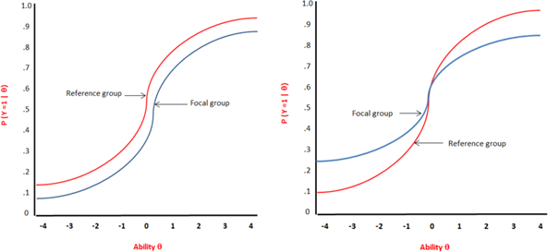

Figure 1. Item Characteristic curves with uniform DIF (left) and non-uniform DIF (right).

Traditionally testing for the presence of DIF under the logistic regression framework is based on likelihood ratio χ2 test (Swaminathan & Rogers, 1990). Initially used for dichotomous items, this technique was then extended for polytomous items, in which case the proportional-odds logistic regression model (Agresti, 1990) is used.

The logistic regression procedure, as used in EMOTION to assess DIF, focuses on one item after the other, looking for differences between groups when participants are matched on similar level of trait. The matching criterion is the IRT score of each factor.

For each item, different nested models are fit to the data to test the null hypotheses (no difference between the groups) and the alternative hypotheses (a: there is a difference between groups or b: there is a difference between groups, and this difference is not constant across all trait levels):

Model 0: logit P(ui ≥ k) = αk
Model 1: logit P(ui ≥ k) = αk + β1 * trait level
Model 2: logit P(ui ≥ k) = αk + β1 * trait level + β2 *group
Model 3: logit P(ui ≥ k) = αk + β1 * trait level + β2 *group + β2 * trait level * group

Where P(ui ≥ k) is the cumulative probabilities that the item response falls in response option k or higher, and αk are the intercepts.

The log-likelihood of each of the 3 models are recorded. Uniform DIF (df = 1) is tested by comparing the log likelihood values for Model 1 and Model 2, non-uniform DIF (df = 1) by comparing Model 2 and Model 3, and the global overall DIF (df = 2) effect by comparing Model 1 and Model 3. These comparisons are performed with the likelihood ratio χ2 statistic.

Criteria for detecting DIF:
Items were flagged as DIF if any of the three likelihood ratio χ2 statistics was significant. Significance level was fixed at alpha =.01 (due to multiple comparison). Moreover, Cox and Snell (1989), Nagelkerke (1991), and McFadden (Menard, 2000) pseudo R2 were reported as a magnitude effects. The level of the effect size provided by the difference

between the R2 coefficients of the nested models were classified as "negligible" (<.13), "moderate" (.13 to .26) or "large" (>.26) based on Zumbo and Thomas’ (1997) scale of DIF effect.

Purification process:
Ordinal logistic regression uses IRT factor scores as a matching criterion for detecting DIF, assuming that all items except the item of interest are DIF free. Iterative purification is a process used in order to determine whether the IRT factor score was already biased prior to running an ordinal logistic regression analysis, due to items with DIF being included in the scale. It iteratively recalculates the matching criterion and the DIF, by using just the items which are identified as non DIF. Iterative purification therefore reduces the effect of DIF on the factor estimates which are used for matching criterion (Choi, Gibbons & Crane, 2011).
Gender and age differences were separately subjected to DIF analyses for each factor. Analyses were performed using R software version 3.3.1 and the Lordif package for R (Choi, Gibbons & Crane, 2011).

Table 15 DIF Table

McFadd en |  |  |  |  |  |  |  |  |  | Nagelkerke |  |  | Cox&Sn ell
Factor | ite m | nca t | chi 12 | chi 13 | ch i2 3 | bet a12 | R2  12 | R2  13 | R2  23 | R2  12 | R2  13 | R2  23 | R2  12 | R2  13 | R2  23
Study Group
Optim ism | 3 | 4 | 0.  00  0 | 0.0  00 | 0.  9  9  3 | 0.0  33 | 0.0  27 | 0.  0  2  7 | 0.0  00 | 0.  0  2  5 | 0.  0  2  5 | 0.  0  0  0 | 0.0  23 | 0.  0  2  3 | 0.0  00
Flexib ility | 2.0  00 | 4.0  00 | 0.  00  0 | 0.0  00 | 0.  9  6  3 | 0.0  72 | 0.0  31 | 0.  0  3  1 | 0.0  00 | 0.  0  3  6 | 0.  0  3  6 | 0.  0  0  0 | 0.0  33 | 0.  0  3  3 | 0.0  00
Self- Contr ol | 2.0  00 | 4.0  00 | 0.  00  8 | 0.0  25 | 0.  6  1  7 | 0.0  09 | 0.0  10 | 0.  0  1  1 | 0.0  00 | 0.  0  2  0 | 0.  0  2  1 | 0.  0  0  1 | 0.0  19 | 0.  0  1  9 | 0.0  01
Self- Contr ol | 4.0  00 | 4.0  00 | 0.  00  0 | 0.0  00 | 0.  6  7  3 | 0.0  74 | 0.0  32 | 0.  0  3  2 | 0.0  00 | 0.  0  4  1 | 0.  0  4  2 | 0.  0  0  0 | 0.0  38 | 0.  0  3  9 | 0.0  00
Self- Motiv ation | 6.0  00 | 4.0  00 | 0.  00  5 | 0.0  19 | 0.  9  9  9 | 0.0  21 | 0.0  11 | 0.  0  1  1 | 0.0  00 | 0.  0  2  3 | 0.  0  2  3 | 0.  0  0  0 | 0.0  21 | 0.  0  2  1 | 0.0  00
Self- Regar d | 2.0  00 | 4.0  00 | 0.  00  0 | 0.0  00 | 0.  8  0  3 | 0.0  78 | 0.0  29 | 0.  0  2  9 | 0.0  00 | 0.  0  4  2 | 0.  0  4  2 | 0.  0  0  0 | 0.0  38 | 0.  0  3  9 | 0.0  00
Self- Regar d | 4.0  00 | 4.0  00 | 0.  00  1 | 0.0  03 | 0.  7  5  8 | 0.0  66 | 0.0  17 | 0.  0  1  7 | 0.0  00 | 0.  0  1  9 | 0.  0  2  0 | 0.  0  0  0 | 0.0  18 | 0.  0  1  8 | 0.0  00
Gend er
Empa thy | 1.0  00 | 4.0  00 | 0.  00  2 | 0.0  09 | 0.  7  0  0 | 0.0  15 | 0.0  14 | 0.  0  1  5 | 0.0  00 | 0.  0  1  6 | 0.  0  1  6 | 0.  0  0  0 | 0.0  14 | 0.  0  1  4 | 0.0  00

Media tion | 1.0  00 | 4.0  00 | 0.  00  2 | 0.0  01 | 0.  0  2  0 | 0.0  16 | 0.0  14 | 0.  0  2  2 | 0.0  08 | 0.  0  2  3 | 0.  0  3  6 | 0.  0  1  3 | 0.0  21 | 0.  0  3  3 | 0.0  12
Self- knowl edge | 2.0  00 | 4.0  00 | 0.  00  0 | 0.0  00 | 0.  6  2  3 | 0.0  31 | 0.0  25 | 0.  0  2  5 | 0.0  00 | 0.  0  2  8 | 0.  0  2  9 | 0.  0  0  0 | 0.0  26 | 0.  0  2  7 | 0.0  00
Self- knowl edge | 3.0  00 | 4.0  00 | 0.  00  9 | 0.0  33 | 0.  8  8  8 | 0.0  76 | 0.0  11 | 0.  0  1  1 | 0.0  00 | 0.  0  2  4 | 0.  0  2  4 | 0.  0  0  0 | 0.0  22 | 0.  0  2  2 | 0.0  00
Tactfu lness | 4.0  00 | 4.0  00 | 0.  00  5 | 0.0  20 | 0.  9  8  1 | 0.0  20 | 0.0  12 | 0.  0  1  2 | 0.0  00 | 0.  0  2  5 | 0.  0  2  5 | 0.  0  0  0 | 0.0  23 | 0.  0  2  3 | 0.0  00

DIF Analysis: Gender
In order to discover if items performed differently across gender, we first defined two groups of professionals by gender (males and females). These analyses were conducted to ensure that all of the items were interpreted in the same way by participants of either gender, and that there was not a bias towards either males or females.

DIF Analysis: Participants
Analyses were conducted with a total of 270 participants all from the UK norm sample. Participants were separated in two groups according to their gender. 153 women (56.67%) aged from 18 to 65 years (M=41.90; SD=12.57) and 117 men (43.33%) aged from 19 to 64 years (M=45.17; SD=12.46) were included in the analysis.

DIF Analysis: Results
Five items were flagged for DIF by gender. Analyses identified one item each for Empathy, Mediation, Tactfulness and two items for Self-Knowledge. No non-uniform DIF was found in these items except for Mediation. However, for all items that were flagged, the size effects, as indicated by the pseudo R2, were all below .04, which is far below Zumbo’s (1999) threshold of .13. Therefore, they are considered negligible.
No DIF was flagged for the other 11 factors and the results of these analyses show that the majority of items (84 out of 89) on EMOTION do not function differently across genders. Table 15 shows the Likelihood Ratio χ2 Statistics for this analysis; all items with demonstrated DIF have been included in this table. Uniform DIF is displayed as χ212, while non-uniform DIF is displayed as χ223, and global DIF is displayed as χ213.

One item displaying DIF was chosen to graphically illustrate uniform DIF in EMOTION with relation to gender. Figure 2 displays analyses of the one item for Empathy, which has negligible gender differences. The focal group (males) is slightly less likely to endorse the item than the focal group (females) for all ability levels. The fourth graph shows the minimal effect size of the item.

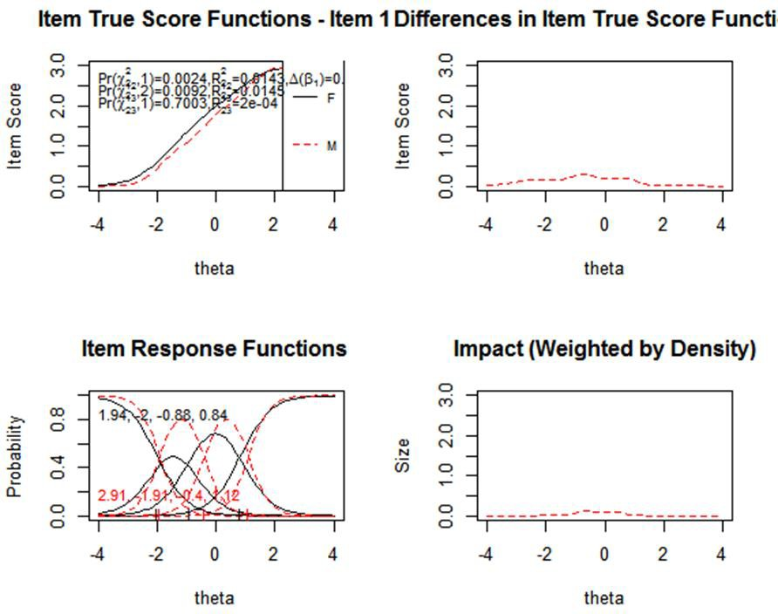

Figure 2. Graphical display of the item "1" for the factor Empathy which illustrates non- uniform DIF with respect to gender.

The top left graph displays the item characteristic curves (ICCs) for the item for male (dotted curve) vs. female (solid curve) professionals based on item true-score functions. The Logistic Regression χ² test for non-uniform DIF (χ²23) was not significant (p=.7), whereas uniform DIF (χ212) was significant (p=.002). The slope of the function for males was slightly lower than that for females at all theta levels, further indicating a uniform DIF.
The top right and the bottom right graphs both show the absolute difference between the ICCs for male and female professionals. The top right graph illustrates the difference in scores between groups along the continuum of trait level (theta score), and shows that the small difference in item true score function is present only at a middle level for the trait Empathy. The bottom right graph shows this same difference in score between groups but weighted by the score distribution of the focal group, thus indicating that the impact of the difference between the item score of the two groups is actually minimal.
The bottom left graph shows the item response functions for the two groups separately for each response options. Slope (discrimination parameter) and category threshold values (difficulty parameters at the intersection of categories response options) are printed on the left of the graph. Difference between groups on the slope parameters (2.91 for men, 1.94 for women) is an indicator of uniform DIF, which is confirmed by the visual inspection of the graph “item true score function” (top left figure). The category threshold values, calculated for each group, indicate at which point of the response option the difference between groups occurs.

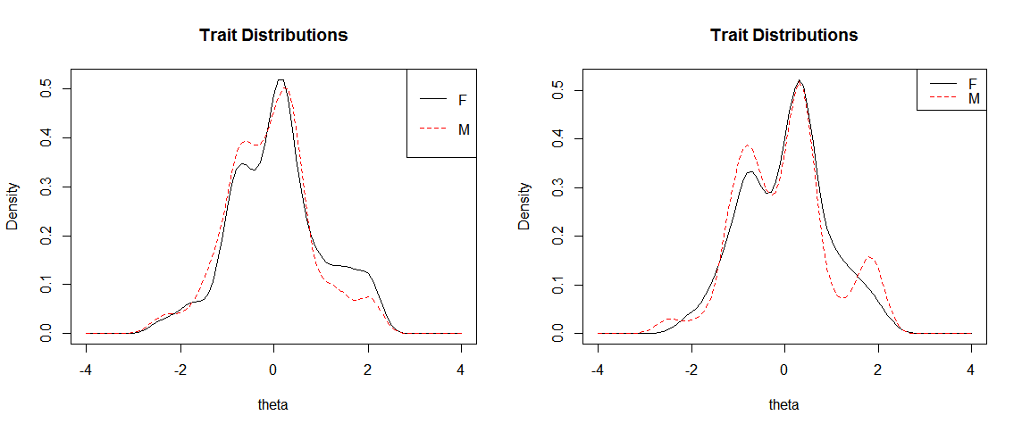
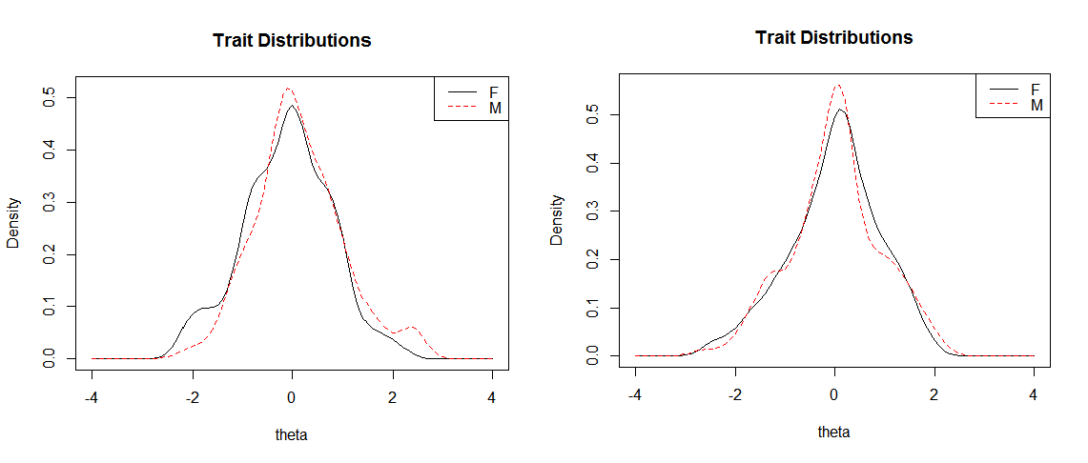
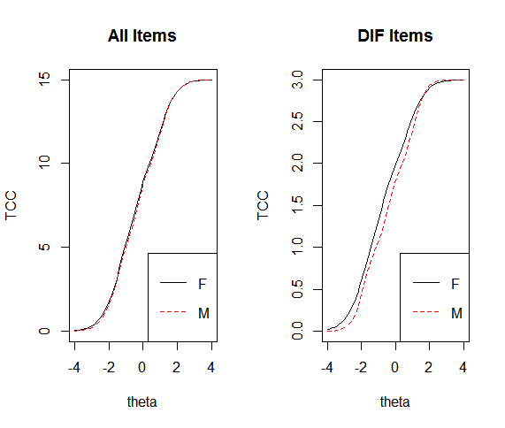
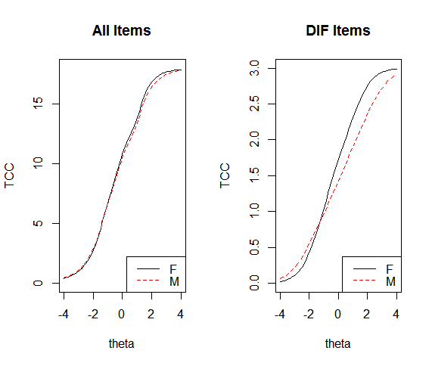
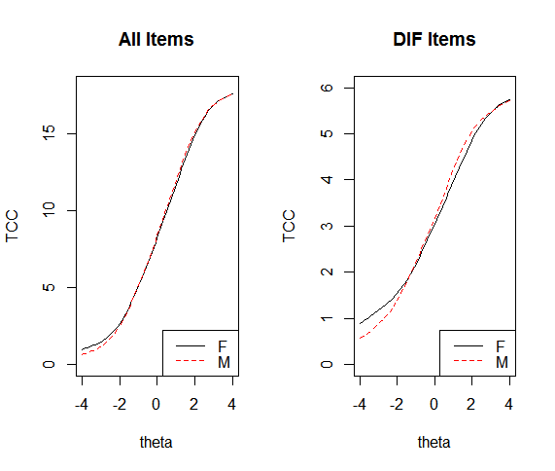
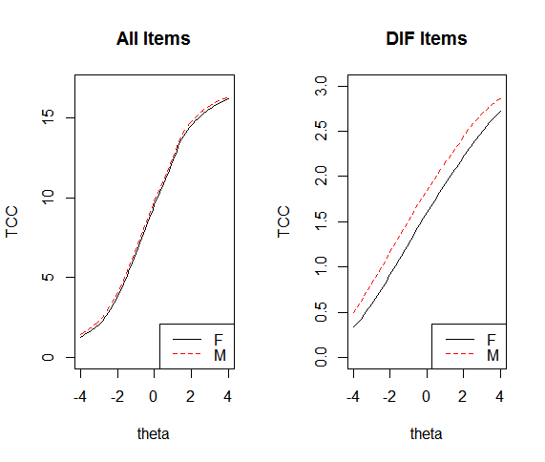
Figure 4. Test Characteristic curves for males and females on the factors: Empathy (Top left), Mediation (Top Right), Self-Knowledge (Bottom left) and Tactfulness (Bottom right)
Figure 3 Trait distributions for the factors Empathy,
Mediation, Self-Knowledge and Tactfulness.

At the trait level, the distributions of the estimated theta scores for Empathy, Mediation, Self-Knowledge and Tactfulness are very similar across both genders and broadly overlap. However there are slight differences: men obtain slightly more medium level theta estimates but less high level estimates than females on empathy. For Mediation the theta estimates are extremely similar but with male estimates fluctuating slightly at the higher theta levels. The Self-Knowledge trait distribution shows that females obtain slightly lower level theta estimates but male obtain more medium and high levels. As for Tactfulness males obtained slightly more mid-level theta estimates (see Figure 3).

The test characteristic curves shown in Figure 4. compare the expected total scores for groups at each level of the underlying trait (theta). This comparison is made with all the items in a factor (the left graph of each pair), and with the subset of items in each factor

found to have DIF (the right graph of each pair). The small area between the curves in the graphs comparing all items for the traits of Empathy, Mediation, Self-Knowledge and Tactfulness, indicate that the DIF items had minimal impact on the total expected score at any level of the underlying trait.

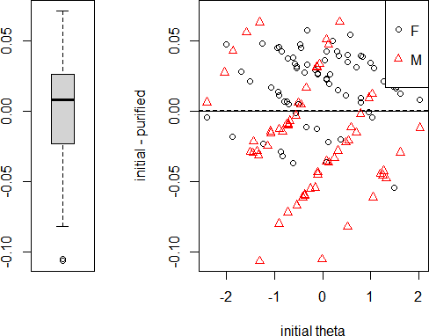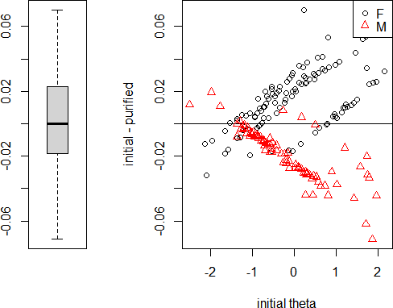

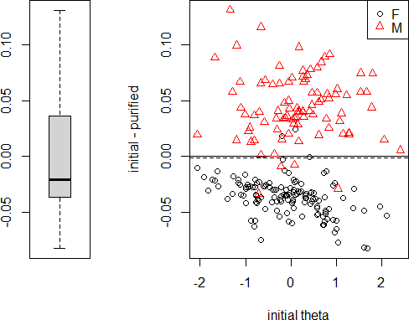
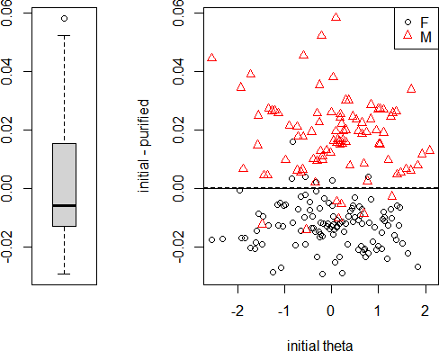

Figure 5. The graph above shows Individual-level DIF impact for Empathy, Mediation, Self-Knowledge and Tactfulness. The graphs above compare the initial theta estimate (which include DIF items) and the purified theta estimates from the final run accounting for DIF. The median difference over all respondents which is represented by the thick black line on the left graph at roughly 0.00. The box and whisker plots all illustrate an interquartile range (the shaded box), ranging from roughly -0.01 to
+0.01. The solid line on the scatterplot illustrates where the median would be if there was no DIF, a dotted line depicts the mean of differences and it is evident that the DIF on these factors is extremely small.

Conclusion: Overall, the results of DIF analyses for gender showed that only 5 items out of 89 displayed a DIF effect. Moreover, the impact of the 5 items with DIF was minimal,

with the effect sizes associated with each item being negligible. Therefore, we can conclude that EMOTION questionnaire is appropriate for use for both male and female professionals without causing any discrimination, and practitioners can be confident of obtaining valid, representative and fair results from its use.

DIF Analysis: Study level
In order to discover if items performed differently across Study level, we defined two groups of professionals by study level, Higher education (Bachelor’s degree and above) and those without higher education. These analyses were conducted to ensure that all of the items were interpreted in the same way by participants regardless of education level, and that there was not a bias towards either.

DIF Analysis: Participants
Analyses were conducted with a total of 270 participants all from the UK norm sample. Participants were separated in two groups according to their study level. The higher education group consisted of 112 participants (41.48%) aged from 20 to 64 years (M=41.21; SD=12.46) and the non-higher educated group consisted of 158 participants (58.52%) aged from 18 to 65 years (M=44.80; SD=12.53).

DIF Analysis: Results

Three items were flagged for DIF by Study level. Analyses identified one item each for Optimism, Resilience, Self-confidence, Self-Knowledge and Self-Motivation. Two items were identified for Self-Regard. No non-uniform DIF was found in any of the items except for resilience, which showed both uniform and non-uniform DIF. The size of the effects however, as indicated by the pseudo R2, were negligible: <.05, which is far below Zumbo’s (1999) threshold of .13 indicating a negligible size effect.
No DIF was flagged for the other 9 factors and the results of these analyses show that the majority of items (82 out of 89) on EMOTION do not function differently across study level. Table 15 shows the Likelihood Ratio X2 Statistics for this analysis; all items with demonstrated DIF have been included in this table. Uniform DIF is displayed as χ212, while non-uniform DIF is displayed as χ223, and global DIF is displayed as χ213.

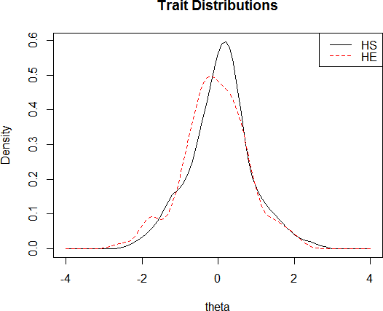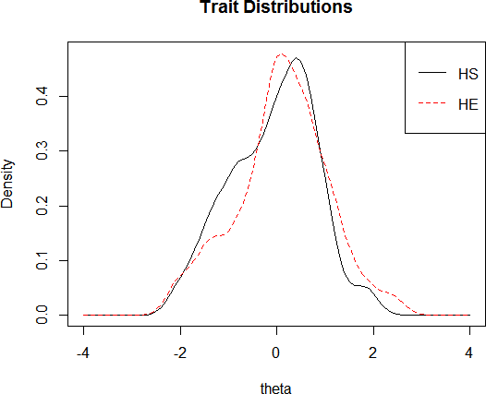

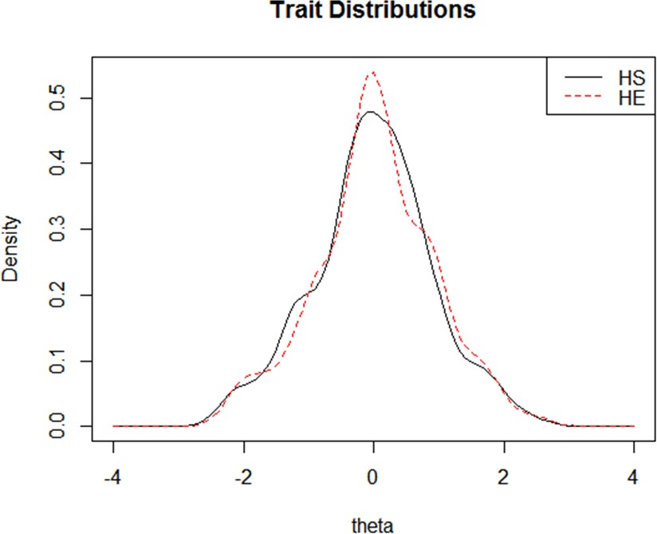
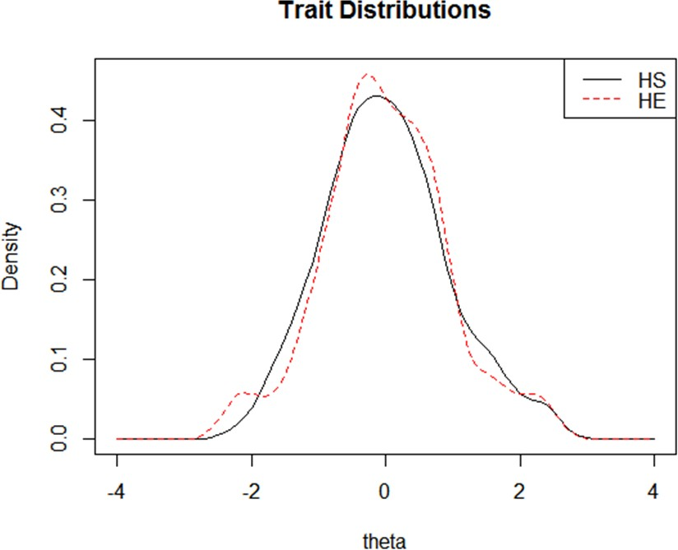
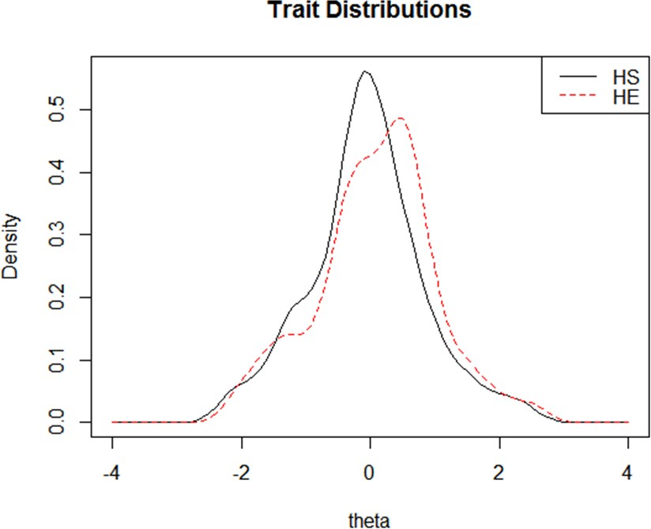

Figure 6. Trait distributions for the factors of Flexibility, Optimism, Self-Control, Self-Motivation and Self-Regard

At the trait level, the distributions of the estimated theta scores for Flexibility, Optimism, Self-Control, Self-Motivation and Self-Regard are very similar across both study levels and broadly overlap. However there are slight differences. The higher education group obtains slightly more medium level theta estimates for the factors of Flexibility and Self- Regard. On the other hand they obtain slightly less medium level theta estimates for the factors of Self-Control and Self-Motivation. These differences are however, negligible (see Figure 6).

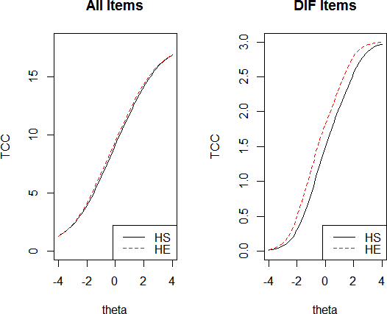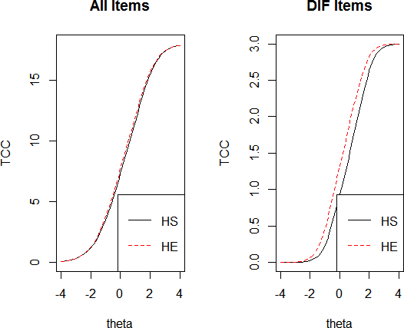
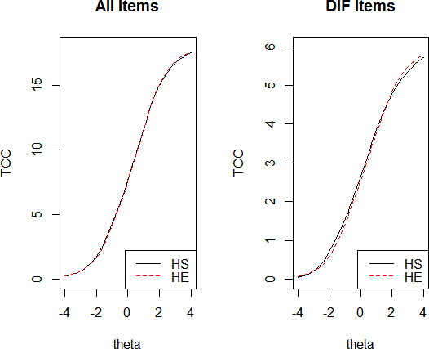
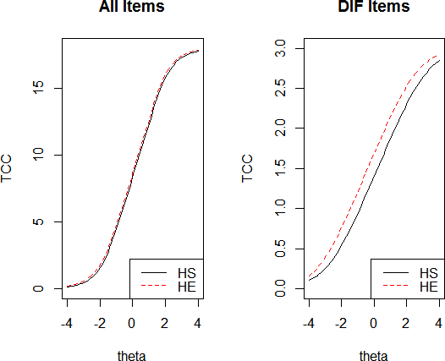

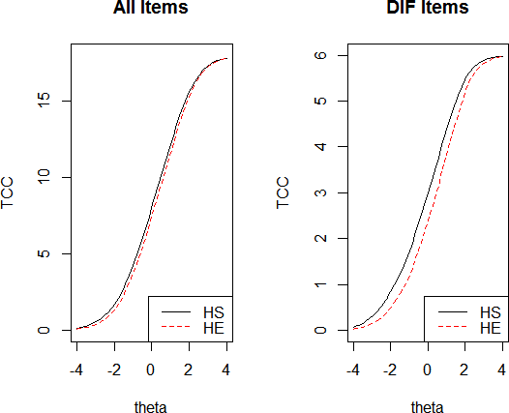

Figure 7. Test Characteristic curves for males and females on the factors: Flexibility (Top left), Optimism (Top Right), Self-Control (Middle left,)Self-Motivation (Middle right) and Self-regard (Bottom left).

The test characteristic curves shown in Figure 7. compare the expected total scores for groups at each level of the underlying trait (theta). This comparison is made with all the items in a factor (the left graph of each pair), and with the subset of items in each factor found to have DIF (the right graph of each pair). The small area between the curves in the graphs comparing all items for the traits of Flexibility, Optimism, Self-Control, Self- Motivation, and Self-regard, indicate that the DIF items had minimal impact on the total expected score at any level of the underlying trait.

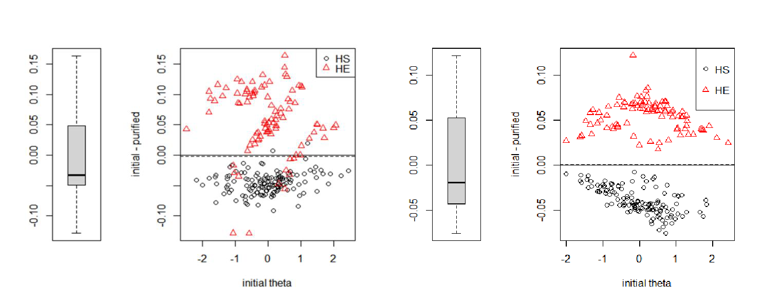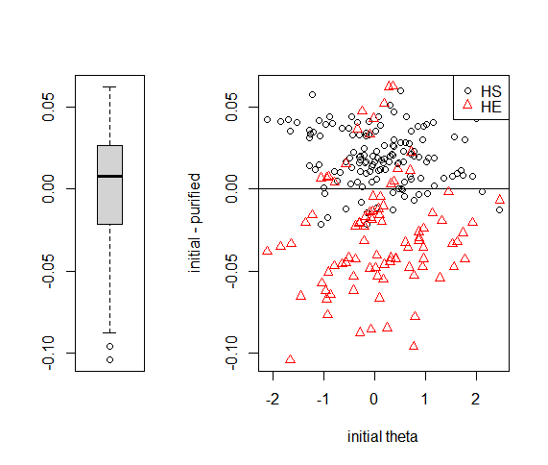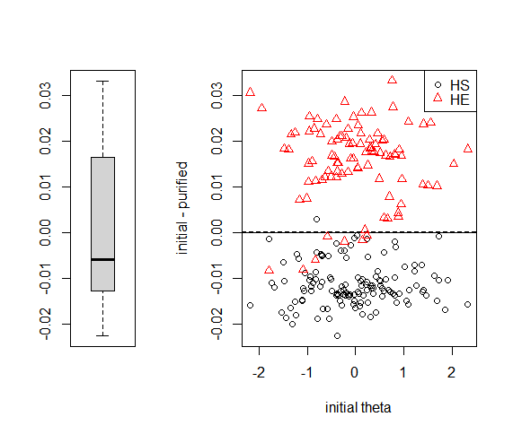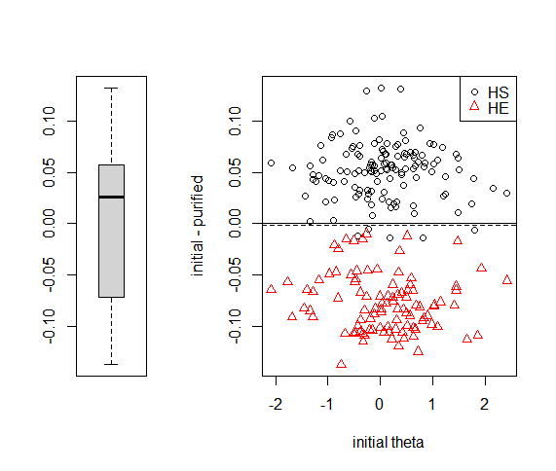

Figure 8. The graph above shows Individual-level DIF impact for Flexibility, Optimism, Self-Control, Self- Motivation and Self-Regard. The graphs above compare the initial theta estimate (which include DIF items) and the purified theta estimates from the final run accounting for DIF. The median difference over all respondents which is represented by the thick black line on the left graph at roughly 0.00. The box and whisker plots all illustrate an interquartile range (the shaded box), ranging from roughly -0.01 to +0.01. The solid line on the scatterplot illustrates where the median would be if there was no DIF, a dotted line depicts the mean of differences and it is evident that the DIF on these factors is extremely small.

Conclusion: The results of DIF analyses for Study level showed that only 7 items out of 89 displayed a DIF effect. Moreover, the impact of the 7 items with DIF was minimal, with the effect sizes associated with each item being negligible. Therefore, we can conclude that EMOTION questionnaire is appropriate for use on all education levels without causing any discrimination, and practitioners can be confident of obtaining valid, representative and fair results from its use.

Overall the results of the DIF analyses for both gender and study level show that 12 items out of 89 were flagged for DIF, however each of these had a negligible effect size. The impact of DIF on the TCCs of all dimension was non-significant and so we know that the EMOTION Questionnaire has a very high consistency of measurement regardless of gender or study level. Therefore we can conclude that EMOTION is an appropriate tool for use and will not cause discrimination based on gender or study level.

    - T-tests and ANOVAs
The DIF analyses demonstrate that EMOTION has high consequential validity and, although a few items were flagged with DIF, they had a negligible impact on the overall assessment meaning that the questionnaire does not have bias towards any gender or study level. Therefore, any significant differences found between genders, age groups, or study levels are due to real differences and not biases of the questionnaire. To further explore the differences between the groups, t-tests and ANOVAS were performed between genders, age groups and study levels (see Tables 16-18).

Gender:
In order to check for differences in scores between genders, an independent samples t- test was conducted to compare all EMOTION factors between females (n=163) and males (n=121).

Table 16 t-Test table

 | Female | Male | T | df | p
Assertiveness | 5.53 | 5.85 | -1.16 | 268 | 0.25
Dealing with Diversity | 4.99 | 4.91 | 0.33 | 268 | 0.74
Empathy | 5.90 | 5.53 | 1.37 | 268 | 0.17
Expressing- Emotions | 4.41 | 4.32 | 0.31 | 268 | 0.76
Flexibility | 5.17 | 5.20 | -0.10 | 216 | 0.92
Mediation | 6.04 | 5.73 | 1.09 | 268 | 0.28
Motivating Others | 6.16 | 5.70 | 1.62 | 268 | 0.11
Optimism | 4.15 | 4.45 | -1.00 | 268 | 0.32
Resilience | 3.96 | 4.31 | -1.14 | 268 | 0.25
Self Confidence | 4.03 | 4.68 | -2.35 | 268 | 0.02*
Self-Control | 4.91 | 5.28 | -1.44 | 268 | 0.15
Self- Knowledge | 4.44 | 4.99 | -2.09 | 268 | 0.04*
Self- Motivation | 4.75 | 4.72 | 0.11 | 268 | 0.91
Self-Regard | 3.97 | 5.02 | -3.72 | 268 | 0.0002*
Tactfulness | 5.97 | 5.99 | -0.09 | 268 | 0.93

There was a significant difference between males and females for 3 of the 15 factors. Males scored significantly higher for Self-Confidence (M=4.68 vs F=4.03) (t(268)= -2.35, p=0.02), Self-Knowledge (M=4.99 vs F= 4.44) (t(268) = -2.09, p = 0.04) and Self-Regard (M=5.02 vs F= 3.97), (t(268) = -3.72, p=0.0002). This possibly confirms some societally constructed stereotypes that men have higher levels of Self-Confidence and Self-Regard than women. As men are expected to be more self-confident they may focus more on developing this aspect of their emotional intelligence than women do. However, due to the fact that no significance was found in any of the other factors, the results also disprove some other stereotypes, such as men being more assertive or women being more empathetic.

Study level:
Participants were separated into five groups according to their study level: Masters and PhDs (n=27), Bachelor’s degrees (n=85), 2 years vocational study (n=60), High school diploma (n=74) and trades training without study (n=24).

Table 17 Study Level ANOVA Table

N=270 | Trades Training  / No studies |  | High school diploma |  | 2 years vocation al study |  | Bachelor ’s degree |  | Masters  / PhD |  | F | p
Factor | Mea n | sd | Mea n | sd | Mea n | sd | Mea n | sd | Mea n | sd
Assertiven | 5.2 | 2.5 | 5.8 | 2.2 | 5.7 | 2.2 | 5.6 | 2.1 | 5.7 | 2.2 | 0.3 | 0.86
ess |  | 1 | 1 | 5 | 6 | 2 | 1 | 9 | 1 | 7 | 3
Dealing with Diversity | 4.7 | 2.0  5 | 4.8  6 | 2.0  4 | 4.9  6 | 2.0  2 | 5.1  8 | 1.9  9 | 4.7  1 | 1.5  6 | 0.5  5 | 0.70
Empathy | 5 | 2.2 | 5.8 | 2.2 | 5.8 | 2.3 | 5.8 | 2.0 | 5.6 | 2.1 | 0.7 | 0.55
 |  | 5 | 3 | 8 |  | 7 | 6 | 2 | 2 | 4 | 6
Expressing | 3.1 | 2.0 | 4.5 | 2.5 | 4.4 | 2.1 | 4.5 | 2.3 | 4.2 | 2.5 | 2.1 | 0.09
Emotions | 8 | 9 | 4 | 5 | 4 | 7 | 5 | 9 | 6 | 8 | 1
Flexibility | 4.8 | 2.2 | 5.0 | 1.7 | 4.9 | 1.8 | 5.4 | 2.0 | 5.5 | 1.1 | 1.1 | 0.34
 | 3 | 1 | 9 | 4 | 5 | 8 | 3 | 4 |  | 9 | 5
Mediation | 4.7 | 2.0 | 5.9 | 2.4 | 5.4 | 2.1 | 6.2 | 2.3 | 6.8 | 2.0 | 4.2 | 0.00
 | 5 | 0 |  |  | 9 | 5 | 4 | 9 | 4 | 5 | 8 | 3*
Optimism | 3.5 | 2.5 | 4.0 | 2.2 | 4.2 | 2.2 | 4.6 | 2.5 | 4.5 | 2.5 | 1.3 | 0.28
 | 4 | 8 | 1 | 9 | 4 | 7 | 6 | 2 | 6 | 1 | 0
Motivating | 4.8 | 2.2 | 5.6 | 2.5 | 6.0 | 1.9 | 6.2 | 2.3 | 6.4 | 2.2 | 2.5 | 0.04
Others | 5 | 7 | 4 | 8 | 9 | 5 | 9 |  | 7 | 4 | 3 | 5*
Resilience | 3.8 | 2.5 | 3.7 | 2.2 | 4.6 | 2.5 | 4.2 | 2.6 | 3.7 | 2.7 | 1.5 | 0.21
 | 5 |  |  | 6 | 8 | 8 | 5 |  | 8 | 4 | 1
Self | 4.3 | 2.4 | 4.1 | 2.1 | 4.3 | 2.3 | 4.5 | 2.3 | 3.9 | 2.2 | 0.3 | 0.83
Confidence | 6 | 6 | 7 | 9 | 3 | 1 | 1 | 3 | 9 | 3 | 7
Self- | 4.9 | 1.4 | 4.6 | 2.2 | 5.4 | 2.3 | 5.3 | 2.0 | 4.6 | 1.6 | 2.0 | 0.09
Control | 2 |  | 1 | 3 | 5 | 8 | 8 | 0 | 9 | 1 | 4
Self- | 4.4 | 2.4 | 4.5 | 2.0 | 4.6 | 1.9 | 5.0 | 2.3 | 4.0 | 2.1 | 1.3 | 0.26
Knowledge | 5 | 9 |  | 6 | 9 | 8 | 8 | 1 | 6 | 9 | 6
Self- | 4.3 | 2.1 | 4.6 | 2.5 | 4.8 | 2.5 | 4.9 | 2.4 | 4.4 | 2.1 | 0.5 | 0.73
Motivation | 5 | 5 | 2 | 2 | 8 |  | 3 | 5 | 5 | 6 | 1
Self- | 4.3 | 2.1 | 4.1 | 2.2 | 4.7 | 2.4 | 4.7 | 2.4 | 3.6 | 2.1 | 1.6 | 0.16
Regard | 5 | 6 | 4 | 3 | 1 | 6 | 4 | 2 | 6 | 5 | 7
Tactfulnes | 5.5 | 2.0 | 5.9 | 1.9 | 5.9 | 2.2 | 6.1 | 1.9 | 5.8 | 1.9 | 0.4 | 0.76
s | 7 | 3 | 9 | 5 | 1 | 7 | 7 | 3 | 9 | 7 | 6

The ANOVA found that there were significant differences for two factors based on study level, which were Mediation and Motivating Others. Post hoc analysis was conducted using pairwise t-tests (bonferroni correction) in order to see where these differences occurred.

The Mediation difference was found to be between the masters/PhD group (M=6.84, SD=2.05) and the trades training group (M=4.75, SD =2.00), p=.012, with all others

being non-significant. This difference might be because to mediate requires analytical skills and being able to find the right arguments to please both parties, which to some degree is learned and improved during higher education.

For Motivating Others, post-hoc t-tests found that there was no significant difference between the five study level groups.

Age:
Participants were separated into six groups according to their age: 18-25 (n=23), 26-33 (n=49), 34-41 (n=44), 42-49 (n=57), 50-56 (n=48) and 57+ (n=49).
Table 18 Age ANOVA Table

N=270 | 18-25 |  | 26-33 |  | 34-41 |  | 42-49 |  | 50-56 |  | 57+ |  | F | Sig
Factor | Me an | sd | Me an | sd | Me an | sd | Me an | sd | Me an | sd | Me an | sd
Assertive | 6.1 | 2. | 5.6 | 2. | 5.6 | 2. | 5.5 | 2. | 5.6 | 2. | 5.7 | 2. | 0. | 0.9
ness | 8 | 29 | 4 | 18 | 2 | 3 | 4 | 6 | 1 | 06 | 2 | 02 | 27 | 3
Dealing with Diversity | 4.5  2 | 2.  19 | 4.6  4 | 2.  12 | 5.0  7 | 1.  7 | 5.0  8 | 1.  78 | 5 | 2.  13 | 5.1  8 | 2.  01 | 0.  60 | 0.7  0
Empathy | 6.4 | 1. | 6.0 | 2. | 5.7 | 2. | 5.4 | 2. | 4.9 | 2. | 6.1 | 2. | 2. | 0.0
 | 1 | 7 | 5 | 09 | 1 | 12 | 7 | 18 | 9 | 46 | 8 | 2 | 28 | 51
Expressi  ng Emotions | 3.7  7 | 1.  96 | 4.1  2 | 2.  63 | 4.9  9 | 2.  38 | 4.2  5 | 2.  59 | 4.5  2 | 2.  15 | 4.3  5 | 2.  34 | 1.  15 | 0.3  4
Flexibilit | 4.9 | 1. | 5.3 | 1. | 5.2 | 2. | 4.8 | 1. | 5.1 | 1. | 5.5 | 1. | 1. | 0.3
y | 3 | 56 | 6 | 84 | 2 | 01 | 2 | 83 | 3 | 98 | 7 | 86 | 05 | 9
Mediatio | 6.2 | 2. | 6.0 | 2. | 6.0 | 2. | 5.2 | 2. | 5.6 | 2. | 6.4 | 1. | 1. | 0.1
n | 7 | 28 | 8 | 55 | 3 | 41 | 9 | 4 | 1 | 15 | 8 | 97 | 90 | 0
Optimis | 4.2 | 1. | 4.4 | 2. | 3.8 | 2. | 3.9 | 2. | 4.2 | 2. | 4.9 | 2. | 1. | 0.2
m | 3 | 7 | 2 | 38 | 5 | 58 | 6 | 49 | 6 | 66 | 2 | 21 | 26 | 9
Motivatin | 6.3 | 2. | 6.1 | 2. | 5.7 | 2. | 5.4 | 2. | 5.9 | 2. | 6.3 | 2. | 1. | 0.3
g Others | 3 | 07 | 9 | 48 | 3 | 53 | 4 | 35 | 9 | 32 | 3 | 05 | 14 | 4
Resilienc | 3.3 | 1. | 4.1 | 2. | 3.7 | 2. | 3.9 | 2. | 4.2 | 2. | 4.8 | 2. | 1. | 0.1
e | 2 | 74 | 8 | 62 | 9 | 57 | 6 | 44 |  | 71 | 1 | 51 | 82 | 1
Self Confiden ce | 3.7  3 | 1.  57 | 4.4  1 | 2.  51 | 4.1 | 2.  27 | 4.0  4 | 2.  34 | 4.3  7 | 2.  26 | 4.9  5 | 2.  22 | 1.  62 | 0.1  6
Self- | 4.5 | 2. | 4.6 | 1. | 5.2 | 2. | 4.9 | 2. | 4.9 | 2. | 5.8 | 1. | 2. | 0.0
Control | 9 | 11 | 7 | 96 | 3 | 03 | 6 | 14 | 4 | 41 | 3 | 77 | 49 | 4*
Self- Knowled ge | 3.9  4 | 1.  59 | 4.6  9 | 2.  56 | 4.6  2 | 2.  25 | 4.3  7 | 1.  71 | 4.6  6 | 2.  44 | 5.4  4 | 2.  07 | 2.  57 | 0.0  3*
Self- Motivatio n | 4.2  2 | 1.  81 | 4.4  2 | 2.  27 | 4.5  5 | 2.  22 | 4.2  8 | 2.  45 | 4.8  2 | 2.  54 | 5.9  2 | 2.  55 | 3.  03 | 0.0  1*
Self- | 4.2 | 1. | 4.3 | 2. | 4.6 | 2. | 4.3 | 2. | 3.9 | 2. | 5.0 | 2. | 1. | 0.2
Regard | 7 | 72 |  | 52 |  | 59 | 2 | 32 | 1 | 23 | 8 | 27 | 42 | 2
Tactfulne | 6.2 | 1. | 5.7 | 2. | 6.1 | 1. | 5.4 | 2. | 5.8 | 1. | 6.8 | 1. | 3. | 0.0
ss | 3 | 59 |  | 18 | 2 | 76 | 2 | 31 | 2 | 97 | 3 | 71 | 28 | 1*

The ANOVA found that there were significant differences for the four factors Self-Control, Self-Knowledge, Self-Motivation and Tactfulness. Post hoc analysis was conducted using pairwise t-tests (Bonferroni correction) in order to see where these differences occurred.
The Self-Control and Self-Knowledge post-hoc t-tests found that there was no significant difference between the six age groups.
The Self-motivation difference was found to be for the 57+ group (M=5.92; SD=2.55) against the 26-33 group (M=4.42; SD=2.27) (p=.03) and the 42-49 group (M=4.28, SD=2.45) (p=.007), while all others are non-significant.
The Tactfulness difference was found to be for the 57+ group (M=6.83; SD=1.71) against the 42-49 group (M=5.42, SD=2.31) (p=.007), while all others are non-significant.
These differences might be due to the fact that emotional intelligence develops with age, so it is to be expected that the older age group has a higher level of emotional intelligence. This is especially true for Tactfulness which is honed through personal experience and which the older age group has in abundance.

References

Barchard, K. A. (2001). Seven components potentially related to emotional intelligence. http://ipip.ori.org

Bandura, A. (1969). Principles of behavior modification. New York: Holt, Rinehart, and Winston, 1969.

Bar-On, R. (1997). The Emotional Quotient Inventory (EQ-i): A test of emotional intelligence.
Toronto, Canada: Multi-Health Systems, Inc.
Bar-On, R., & Handley, R. (2003). The Bar-On EQ-360. Toronto, Canada: Multi-Health Systems. Brans, K., Van Mechelen, I., Rimé, B., & Verduyn, P. (2014). To share, or not to share?
Examining the emotional consequences of social sharing in the case of anger and
sadness. Emotion, 14(6), 1062.

Bush, R. A. B. (1996). What do we need a mediator for?: Mediation's "value-added" for negotiators. Ohio State Journal on Dispute Resolution, 12, 1-36.

Cherniss, C., & Goleman, D. (2001). Emotional Intelligence: Issues in Paradigm Building. People Management, 7(8), 60.

Conn, S. R., & Rieke, M. L. (1994). The 16PF with edition technical manual. Champaign, IL: Institute for Personality and Ability Testing.

Costa Jr, P. T., & McCrae, R. R. (1992). Revised NEO personality inventory (NEO-PI-R) and NEO five-factor (NEO-FFI) inventory professional manual. Odessa, FL: PAR.

Crombie, D. T., Lombard, C., & Noakes, T. D. (2009). Emotional intelligence scores predict team sports performance in a national cricket competition. International Journal of Sports Science and Coaching, 4, 209-224.

Cronbach, L. J., & Meehl, P. E. (1955). Construct validity in psychological tests. Psychological Bulletin, 52(4), 281‑ 302. doi.org/10.1037/h0040957

Day-Vines, N. L., Day-Hairston, B. O., Carruthers, W. L., Wall, J. A. & Lupton-Smith, H. A. (1996). Conflict resolution: The value of diversity in the recruitment, selection, and training of peer mediators. The School Counselor, 43, 392-410.

Depner, C. E., Cannata, K. & Ricci, I. (1994). Client evaluations of mediation services: The impact of case characteristics and mediation service models. Family and Conciliation Courts Review, 32, 306-25.

Dodou, D., & De Winter, J. C. F. (2014). Social desirability is the same in offline, online, and paper surveys: A meta-analysis. Computers in Human Behavior, 36, 487-495.

Fan, X., Thompson, B., & Wang, L. (1999). Effects of sample size, estimation methods, and model
specification on structural equation modeling fit indexes. Structural Equation Modeling: A Multidisciplinary Journal, 6(1), 56-83.
Fisher, R. J. (1997). Interactive conflict resolution. Syracuse, NY: Syracuse University Press. Frattaroli, J. (2006). Experimental disclosure and its moderators: a meta-analysis. Psychological
Bulletin, 132(6), 823.

Goldberg, L. R., Johnson, J. A., Eber, H. W., Hogan, R., Ashton, M. C., Cloninger, C. R., & Gough, H. C. (2006). The International Personality Item Pool and the future of public- domain personality measures. Journal of Research in Personality, 40, 84-96

Goleman, D. (1995). Emotional Intelligence, Bantam Books, New York, NY.
Goleman, D. (1998). Working with emotional intelligence, Bantam Books, New York, NY. Goleman, D. (2000). Emotional intelligence: Issues in paradigm building. In Goleman, D. &
Cherniss, C. (eds.). The Emotionally Intelligent Workplace: How to Select for, Measure, and Improve Emotional Intelligence in Individuals, Groups, and Organizations. San Francisco, CA: Jossey-Bass.

Gonzalez, J. A., & Denisi, A. S. (2009). Cross‐level effects of demography and diversity climate on organizational attachment and firm effectiveness. Journal of Organizational Behavior, 30(1), 21-40.

Gough, H. G., & Bradley, P. (1996). CPI manual (third ed.). Palo Alto, CA: Consulting Psychologists Press.

Holtzman, S., & Vezzu, S. (2011). Confirmatory Factor Analysis and Structural Equation Modeling of Noncognitive Assessments using PROC CALIS. Retrieved from http://www.lexjansen.com/nesug/nesug11/sa/sa07.pdf

Hooper, D., Coughlan, J., & Mullen, M. (2008). Structural equation modelling: Guidelines for determining model fit. Articles, 2.

Hu, L., & Bentler, P. M. (1999). Cut-off criteria for fit indexes in covariance structure analysis: Conventional criteria versus new alternatives. Structural Equation Modeling: A Multidisciplinary Journal, 6(1), 1‑ 55. doi.org/10.1080/10705519909540118

Johnson, D. W. & Johnson, R. T. (1996). Conflict resolution and peer mediation programs in elementary and secondary schools: A review of the research. Review of Educational Research, 66, 459-506.

Johnson, D. W., Johnson, R. T., Dudley, B., Ward, M. & Magnuson, D. (1995). The impact of peer mediation training on the management of school and home conflicts. American Educational Research Journal, 32, 829-44.

Jöreskog, K. G., & Sörbom, D. (1993). LISREL 8: Structural Equation Modeling with the SIMPLIS Command Language. Scientific Software International.

Joseph, K. L. (1996). Victim-offender mediation: What social and political factors will affect its development? Ohio State Journal on Dispute Resolution, 11, 207-25.

Joseph, D. L., & Newman, D. A. (2010). Emotional intelligence: an integrative meta-analysis and cascading model. Journal of Applied Psychology, 95(1), 54.

Kellett, J. B., Humphrey, R. H. & Sleeth, R. G. (2002). Empathy and Complex Task Performance: Two Routes to Leadership. The Leadership Quarterly, 13, 523–44.

Kellett, J. B., Humphrey, R. H. & Sleeth, R. G. (2006). Empathy and the Emergence of Task and Relations Leaders. The Leadership Quarterly, 17, 146–62.

Keikhayfarzaneh, M. M. (2011). The effectiveness of group assertive training on social anxiety, Academic Success and social skills among male students of Iranshahar High Schools.
Journal of Educational Psychology, 2, 103-116.

Kennedy-Moore, E., & Watson, J. C. (2001). How and when does emotional expression help?
Review of General Psychology, 5, 187–212. doi:10.1037/1089-2680.5.3.187

Lin, Y. R., Shiah, I. S., Chang, Y. C., Lai, T. J., Wang, K. Y., & Chou, K. R. (2004). Evaluation of an assertiveness training program on nursing and medical students’ assertiveness, self- esteem, and interpersonal communication satisfaction. Nurse education today, 24(8), 656-665.

Littrell, J. (2008). The status of Freud’s legacy on emotional processing: Contemporary revisions. Journal of Human Behavior in the Social Environment, 18, 477– 499. doi:10.1080/10911350802487245

Luthans, K. W., Lebsack, S. A., & Lebsack, R. R. (2008). Positivity in healthcare: relation of optimism to performance. Journal of health organization and management, 22(2), 178- 188.

Martins, A., Ramalho, N., & Morin E. (2010). A comprehensive meta-analysis of the relationship between emotional intelligence and health. Personality and Individual Differences, 49, 554–564.

Mayer, J. D., Caruso, D. R., & Salovey, P. (2000). Selecting a measure of emotional intelligence: The case of ability scales. In Bar-On, R. & Parker, J. D. A. (Eds.). The handbook of emotional intelligence (pp. 320–342). San Francisco: Jossey-Bass.

Mayer JD, Salovey P, Caruso (2002). Mayer-Salovey-Caruso Emotional Intelligence Test (MSCEIT) Item Booklet. Toronto: MHS Publ.

Malouff, J. M., Schutte, N. S., & Thorsteinsson, E. B. (2014). Trait emotional intelligence and romantic relationship satisfaction: A meta-analysis. The American Journal of Family Therapy, 42(1), 53-66.

Mayer, J. D., & Salovey, P. (1997). What is emotional intelligence? In Salovey, P. & Sluyter, D. (Eds.), Emotional development and emotional intelligence: Educational implications. New York: Basic Books.

Mehrabizade, M. H., Taghavi, S. F., & Attari, Y. A. (2009). Effect of group assertive training on social anxiety, social skills and academic performance of female students. International Journal of Behavioral Sciences, 3(1), 59-64.

Mischel, W. (1968). Personality and assessment. New York: Wiley. Nunnally, J. C. (1978). Psychometric theory. New York: McGraw-Hill.
O'Boyle, E. H., Humphrey, R. H., Pollack, J. M., Hawver, T. H., & Story, P. A. (2011). The relation between emotional intelligence and job performance: A meta‐analysis. Journal of Organizational Behavior, 32(5), 788-818.

Petrides, K. V., & Furnham, A. (2001). Trait emotional intelligence: Psychometric investigation with reference to established trait taxonomies. European Journal of Personality, 15, 425– 448.

Rasmussen, H. N., Scheier, M. F., & Greenhouse, J. B. (2009). Optimism and physical health: A meta-analytic review. Annals of behavioral medicine, 37(3), 239-256.

Richard, O. C., Barnett, T., Dwyer, S., & Chadwick, K. (2004). Cultural diversity in management, firm performance, and the moderating role of entrepreneurial orientation dimensions. Academy of Management Journal, 47(2), 255-266.

Sacco, J. M., & Schmitt, N. (2005). A dynamic multilevel model of demographic diversity and misfit effects. Journal of Applied Psychology, 90(2), 203.

Salovey, P., & Mayer, J. D. (1990). Emotional intelligence. Imagination, cognition and personality, 9(3), 185-211.

Sadri, G., Weber, T. J., & Gentry, W. A. (2011). Empathic emotion and leadership performance: An empirical analysis across 38 countries. The Leadership Quarterly, 22(5), 818-830.

Scheff, T. (2007). Catharsis and other heresies: A theory of emotion. Journal of Social, Evolutionary, and Cultural Psychology, 1, 98 –113.

Schlaerth, A., Ensari, N., & Christian, J. (2013). A meta-analytical review of the relationship between emotional intelligence and leaders’ constructive conflict management. Group Processes & Intergroup Relations, 16(1), 126-136.

Schreiber, J. B., Nora, A., Stage, F. K., Barlow, E. A. & King, J. (2006). Reporting Structural Equation Modeling and Confirmatory Factor Analysis Results: A Review. The Journal of Educational Research, 99(6), 323‑ 338. doi.org/10.3200/JOER.99.6.323-338

Schutte, N. S., Malouff, J. M. & Thorsteinsson, E. B. (2013). Increasing emotional intelligence through training: Current status and future directions. International Journal of Emotional Education, 5(1), 56.

Schutte, N. S., Malouff, J. M., Thorsteinsson, E. B., Bhullar, N. & Rooke, S. E., (2007). A meta- analytic investigation of the relationship between emotional intelligence and health.
Personality and Individual Differences, 42, 921-933.

Scott, B. A., Colquitt, J. A., Paddock, E. L. & Judge, T. A. (2010). A Daily Investigation of the Role of Manager Empathy on Employee Well-Being. Organizational Behavior and Human Decision Processes, 113, 127–40.

Shulman, H. A. (1996). Using developmental principles in violence prevention. Elementary School Guidance and Counseling, 30, 170-79.

Smith, E. (1996). Danger-inequality of resources present: Can the environmental mediation process provide an effective answer? Journal of Dispute Resolution, 379-400.

Stanton, A. L. & Low, C. A. (2012). Expressing Emotions in Stressful Contexts Benefits, Moderators, and Mechanisms. Current Directions in Psychological Science, 21(2), 124- 128.

Steiger, J. H. & Lind, J. C. (1980). Statistically based tests for the number of common factors.
In annual meeting of the Psychometric Society, Iowa City, IA, 758.

Thorndike, E.L. (1920). Intelligence and its uses. Harper’s Magazine, 140, 227-235.

Touval, S. (1996). Coercive mediation on the road to Dayton. International Negotiation, 1, 547- 570.

Ullmann, L. P. & Krasner, L. (1965). Case studies in behavior modification. New York: Holt, Rinehart, and Winston.

Whelton, W. J. (2004). Emotional processes in psychotherapy: Evidence across therapeutic modalities. Clinical Psychology & Psychotherapy, 11.

Contact Us  Training and Consulting: consulting@centraltest.com  Client Service: customer@centraltest.com  www.centraltest.com | 

France  28 Boulevard de la Bastille 75012 Paris | United Kingdom 1-3 Brixton Road SW9 6DE London
India  15, KMJ Arcadia, Industrial Main Road Koramangala 5th Block  Bangalore | Madagascar  Domaine d'Ankatso #13, Ambohidepona, 1O1,  Antananarivo

